niceneasy Office

The niceneasy Office has been designed to help you manage customers, work and to generate quotes. It also has reporting functions to help you review your business performance.

Contents
Dashboard 4
My Enquiries 4
My Appointments 4
My Reminders 4
My To-Do List 5
My Recent Quotes 5
Customers 6
Add Customers 6
Customer Overview 7
Future Work 8
Past Work 8
Chemical Records 9
Commercial Works 9
Quotes 10
Worksheets 11
Complete Job 12
Admin 14
My Work 14
Schedule Work 14
Historical Worksheets 17
Quotes 17
My Reminders 21
My To-do List 22
My Appointments 23
23
Add Appointment 24
Email Appointment Reminders 26
Marketing 28
Weekly Marketing Checklist 28
Marketing Templates 29
Marketing Campaign 29
Purchasing 30
View Supplier Details 31
Order Items 31
Message System 32
Reports 34
Weekly Returns 34
Commercial Works 35
Income Works Analysis 35
Supplier Spend Analysis 36
Customer Lead Report 36
Total Herbicide, Selective Herbicide, Lawn Feed and Pesticide Records 37
Resources 37
View Resources 37
Documents 37
Price List 38
Video 38
Settings 39
My Details 39
My Services 40
Manage Users 40
My Vans 40
Customer Source 41
Work Patterns 41

Dashboard
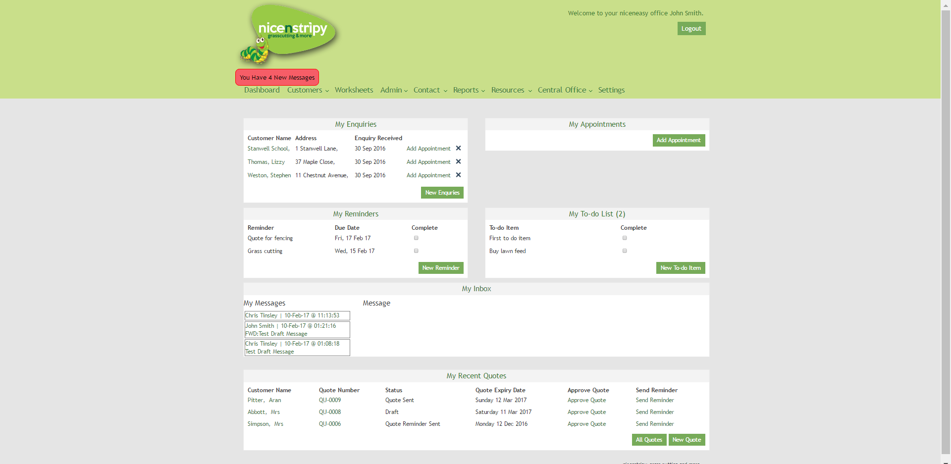
On entering the niceneasy office, you will arrive at your dashboard, this is your home screen with an overview of Recent Enquiries, Appointments, Reminders, To-Do List, your Inbox which includes your 5 most recent messages and Recent Quotes. You will also notice a red box under the nicenstripy logo, if you have any messages on our internal messaging system you will be notified here throughout the office system. If you have no unread messages then you will not see the notification.

My Enquiries
Any customers found in the ‘My Enquiries’ section will have come from the nicenstripy website. If you click the ‘New Customer’ button in this section, you will be directed to a screen to add a new customer, once saved, this customer will be listed as a New Enquiry in your customer database rather than an Active Customer. You can schedule an appointment or remove the enquiry from this section clicking the ‘Add Appointment’ or ‘X’ buttons as required

My Appointments
The ‘My Appointments’ section shows the next 10 appointments in your diary from the current date forward. From this section you can add a new appointment through clicking the ‘Add Appointment’ button. Edit an appointment by clicking the appointment Title and record the Outcome of an appointment. If the tick is clicked, an appointment is marked as successful and will be recorded on the weekly return as a presentation. If the cross is clicked, you are presented with two options, you can either delete the appointment or re-schedule the appointment for a future date.

My Reminders
In this section, you can set reminders pertaining to customers whose details you already have stored. Clicking ‘new reminder’ will take you to a form to add a title, due date and notification date for your reminder, as well as any general notes. You can also choose to repeat the reminder by ticking the checkbox at the bottom of the form; this allows you to repeat the reminder a certain number of times every day, week, month or year. For example, repeating a reminder four times every year will result in quarterly reminders. Reminders are for time-sensitive items, such as reminding to contact a customer regarding an annual service or getting your vehicles and equipment services. To mark a reminder as completed simply click the tick box.

My To-Do List
Here, you can view existing items on your to-do list and add new ones. These are for simple tasks that can be explained in a sentence like ordering more lawn feed. To mark a To-Do item as completed simply click the tick box.

My Inbox
Here, you can view your 5 most recent messages. Click a message name or subject to view/read the message, you will also be given options to reply, reply all, forward or delete the message. Your full inbox can be accessed via the messenger centre or using the ‘My Inbox’ link.

My Recent Quotes
The ‘My Recent Quotes’ section lists recent quotes which are either in ‘Draft’ or ‘Quote Sent’ status. Within this section you can create a new quote through clicking the ‘New Quote’ button, view all quotes by clicking the ‘All Quotes’ button, view and edit a quote clicking the customer name or the quote number and finally, approve a quote by clicking the ‘approve quote’ link. You can also send a reminder using the office system to email the client a copy of the quote again. You will be presented with an email template to review and approve before sending the quote reminder.

Customers
The customer overview section allows you to quickly view your customers divided under three headings, ‘Active Customers’, ‘Recent Enquiries’ and ‘Past Customers’. Active Customers are those who you currently do work for, Past Customers are customers you have worked for but no longer do work for and Recent Enquiries are customers you have added or who have come through the website but aren’t actual customers. You can also see all your customers in a single list.
From this screen you can search your customers, add new customers, or edit existing customers. Clicking the ‘export customers’ button will produce a downloadable Excel spreadsheet with all your customers’ details in mirroring the current customer view.
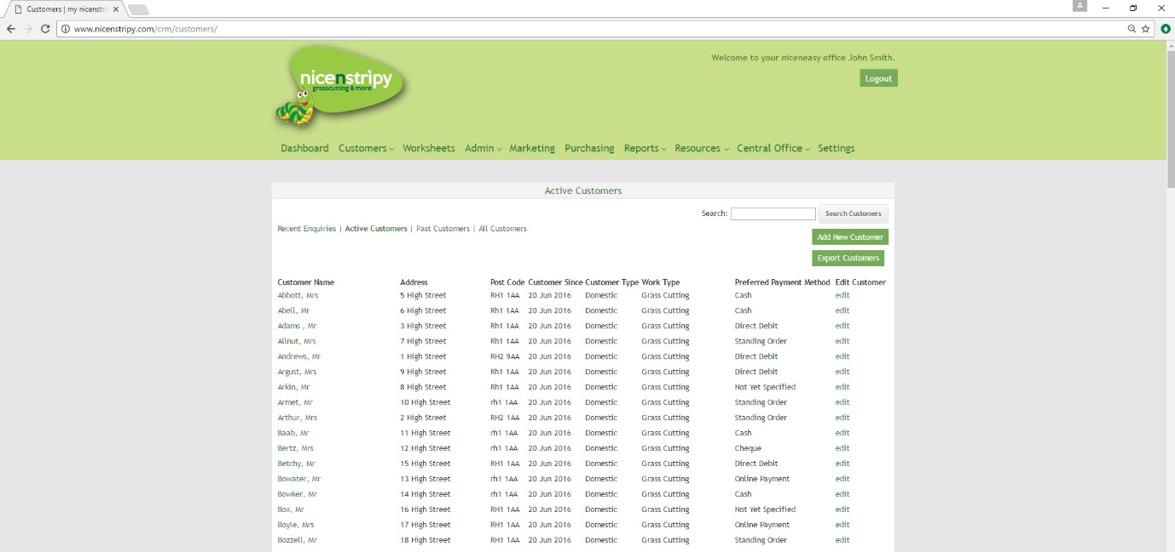

Add Customers
When adding a customer, you are asked to complete as many fields as possible, but the only required field is ‘Company/Surname’. We encourage you to complete the ‘Customer Source’ option in order to analyse where your customers come from using the in-built analysis reporting tool.
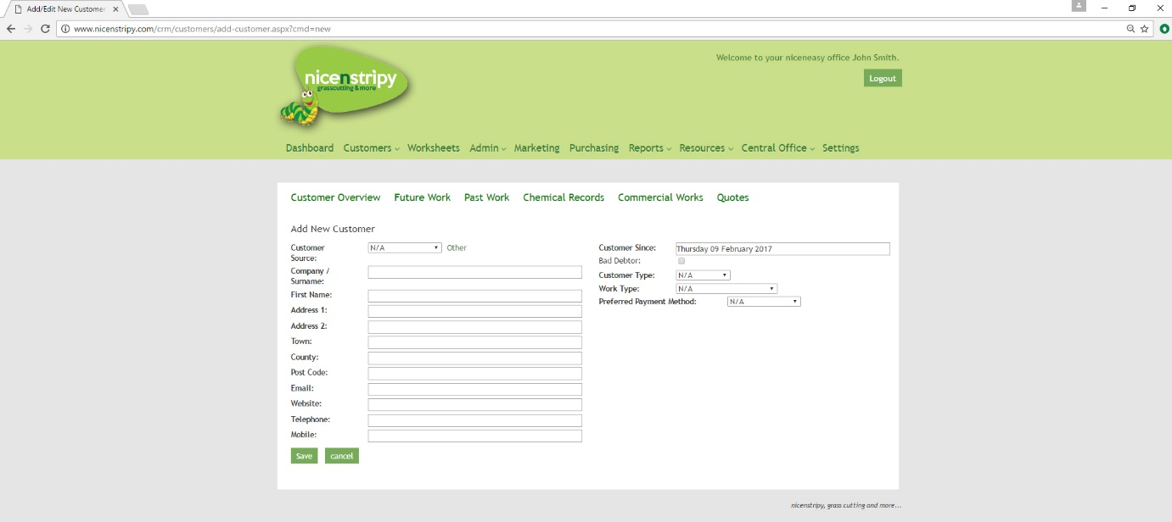

Customer Overview
When you view a customer, all the information linked to their account is shown under various tabs. To view any of this information simply click a tab.
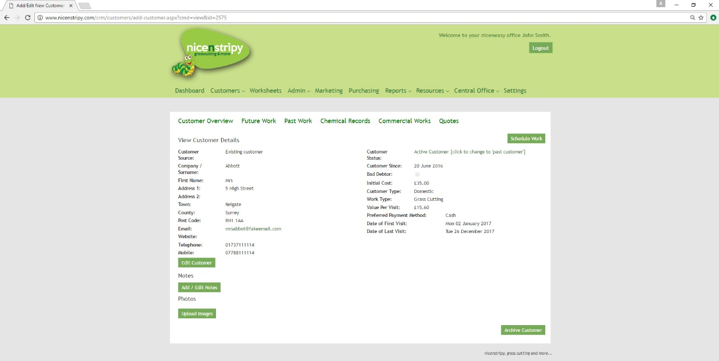
On the Customer Overview page it is possible to edit the customer information, Add/Edit notes linked to the customer, Upload Images for the customer, Schedule Work for the Customer, Update the Customer Status and Archive the Customer.
If you choose to archive a customer you are presented with a warning.
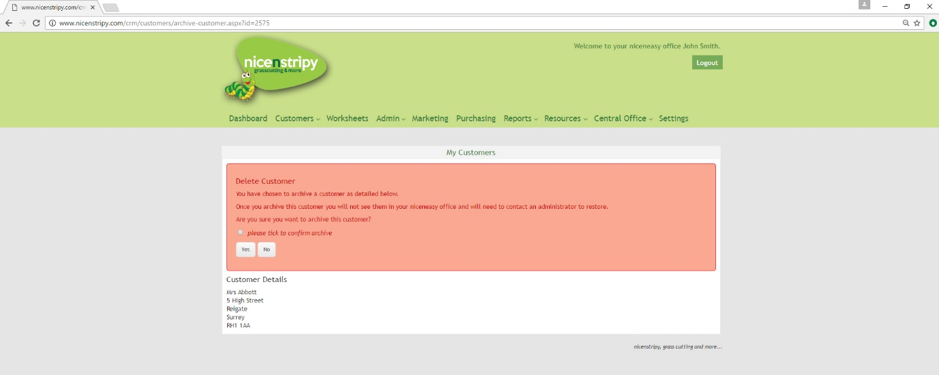
As explained, archiving a customer will remove them entirely from your niceneasy office.

Future Work
Future Work presents all future work for this customer and allows you to edit and delete the work.
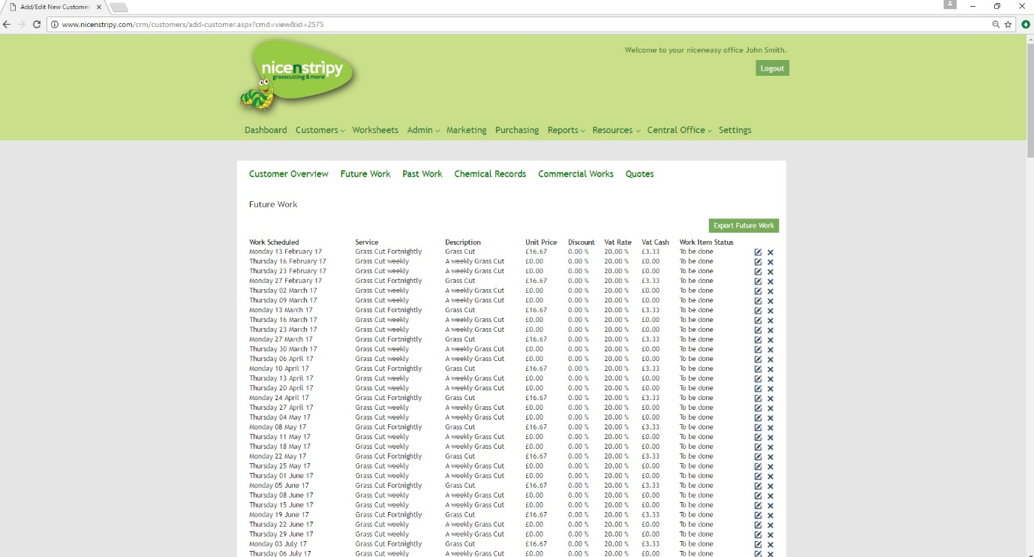

Past Work
Past Work shows all past work and its status following completion of the Work Sheet
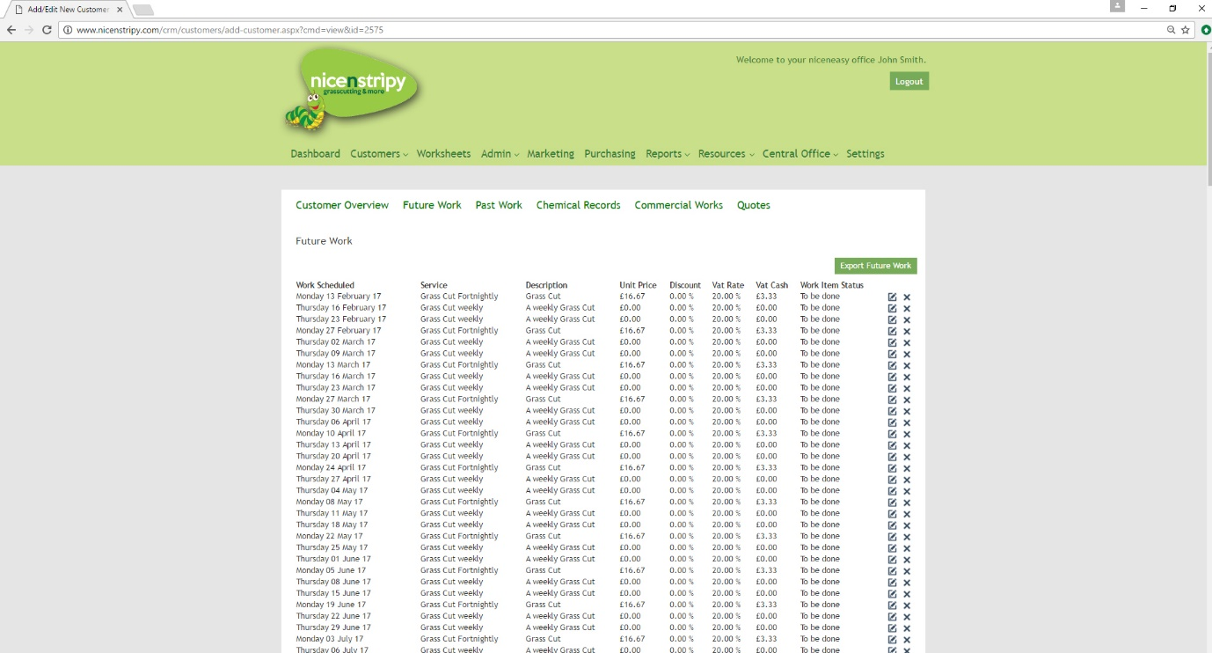

Chemical Records
Chemical Records shows the most recent recorded information for each type of chemical record and allows you to view all historical data by each customer.
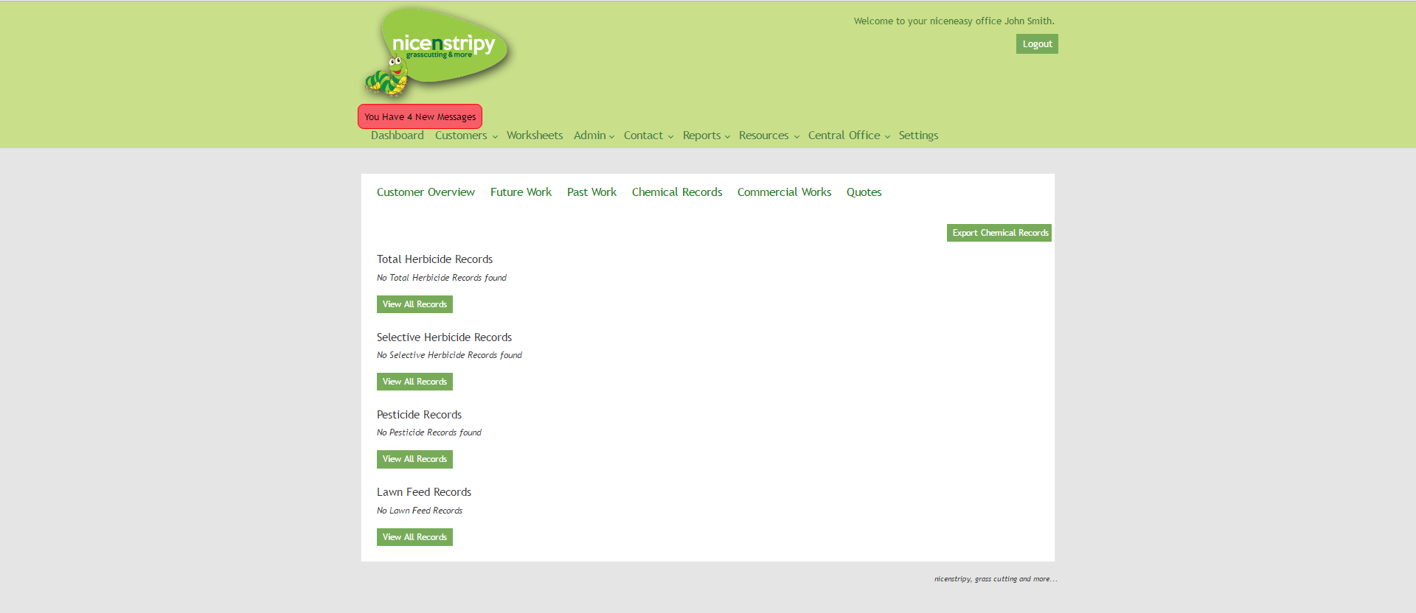

Commercial Works
The Commercial Works section shows an overview of each entry for commercial works, the summery presents the date of the work, arrival and departure time, hours worked, men on the job and total hours worked. The job value and the revenue per man hour. The system also calculates the total value and man hours for all commercial works under this customer giving you the average revenue per man hour.
To view what commercial works were entered onto the system on completion click the ‘View Info.’ Button.
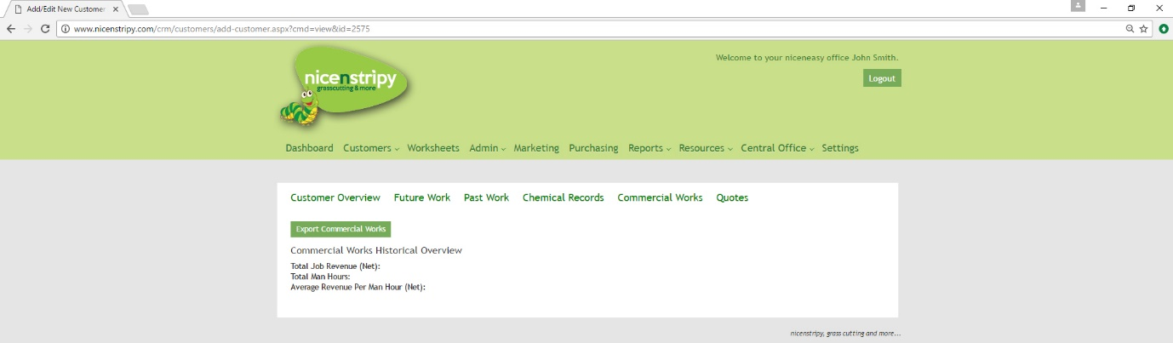

Quotes
Quotes shows and allows you to edit quotes linked to the customer. To edit a quote, simply click the Quote Number.
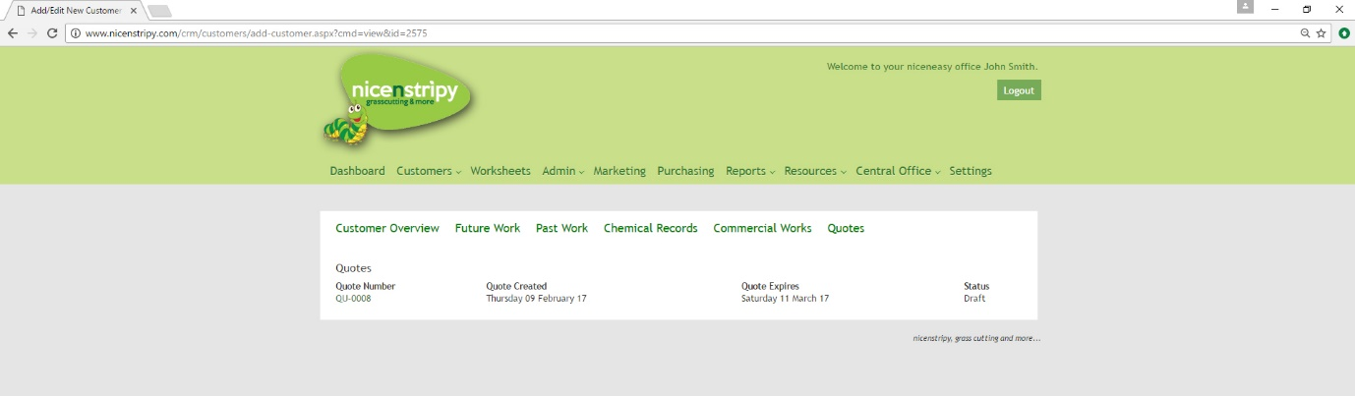

Worksheets
You can access the work sheet from the main navigation bar. The Work Sheet works on fortnightly blocks, showing the current week and next week, you can cycle through each day by selecting the appropriate day and date, click ‘Next Week’ or ‘This Week’ to cycle between weeks. The day that the work is being shown for will appear in bold.
From this screen it is also possible to ‘Edit the Order of Work’ for that day, click the link and you are able to drag and drop the work into your preferred order, you are also presented with an ‘Order of Work’ column, confirm the order of work by entering numbers into the boxes, the lowest coming first and the highest number being last and save. It is possible to save just that day’s work or all future work sheets through clicking the appropriate button.
Clicking the ‘export worksheets’ button will generate a form for you to fill out in order to download a spreadsheet of work between two dates.

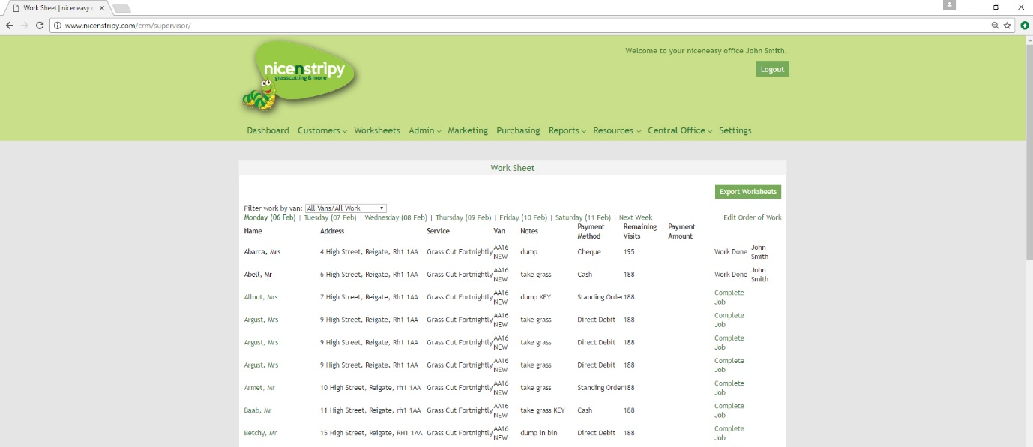

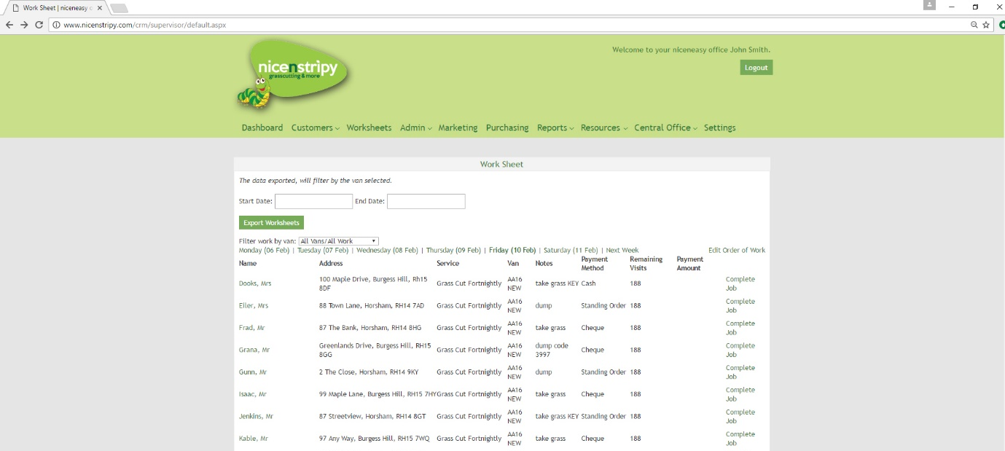

Complete Job

On the work sheet, besides every job there is an option to ‘Complete Job’, select this to complete the job. Once a job has been completed the status of the that work is recorded on the system and shows on the Work Sheet, this will be ‘Work Done’ or ‘Work Incomplete’ to reflect the outcome of the work. If a job wasn’t completed the system asks for a reason to be recorded and it is possible to access this through clicking the customer name.

When completing a job, you are taken through a series of questions, ‘Did you visit the site?’ Did you Complete the Job? If no is selected for either of these, the user is asked to record the reason for not completing the work and this is recorded on the system.

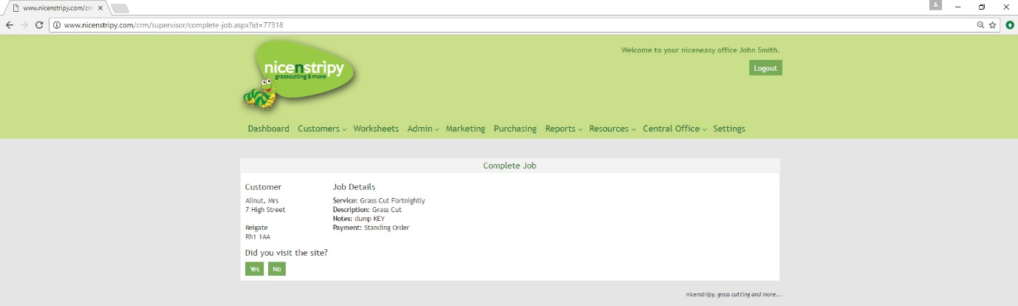
If a job is completed and the service was listed as Domestic Maintenance or Commercial Maintenance you are asked to complete the commercial works sheet. The data recorded under Commercial Works can be viewed for each customer and a history of the services undertaken viewed for each day. The system will also show you the time spent and the revenue per man hour taken to complete the work.
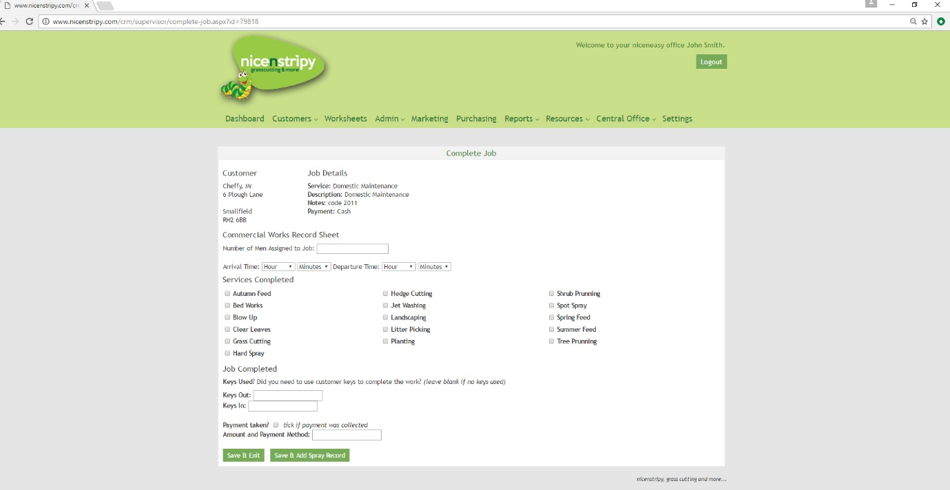
If a job includes the application of any chemicals you are also prompted to record the necessary information and this is logged under the customer record and under the appropriate reports.
For any other service you are simply asked to record the basic information
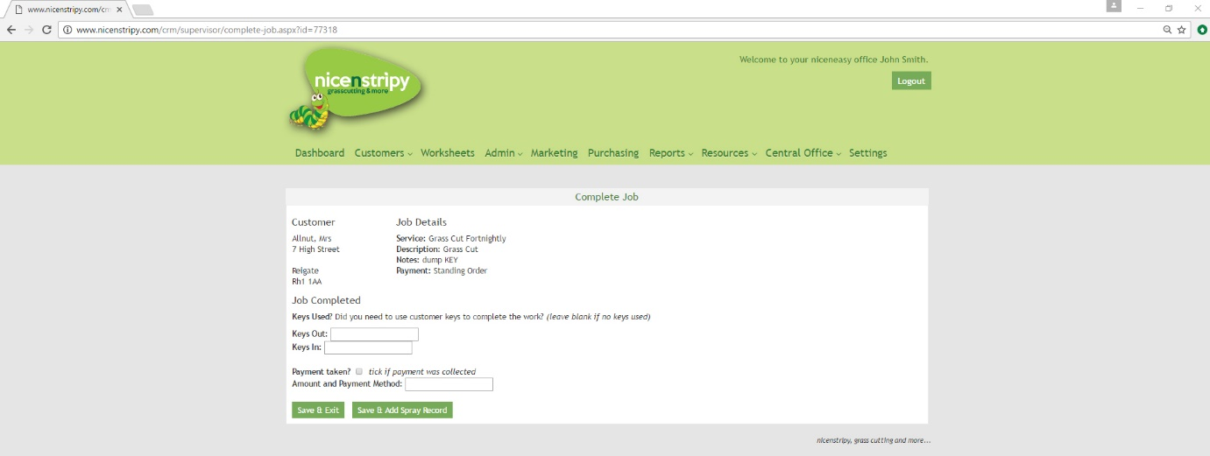
Click Save to complete a job.
On this screen you can also view and edit the mileage for each van for that day and also record the weather conditions, the weather conditions will feed into your weekly return.
To edit either item, simply click the ‘Edit Van Details’ or ‘Record Weather’ button, complete the relevant fields and click Save
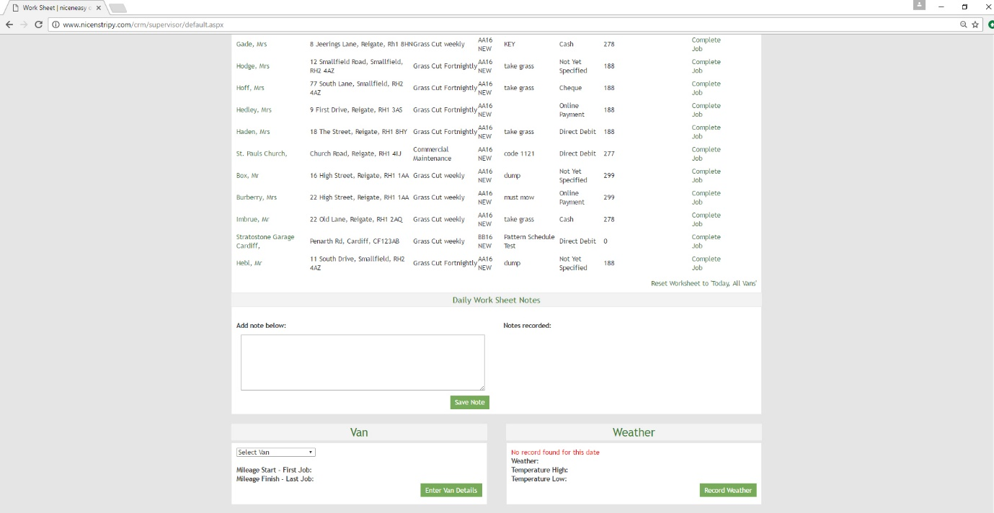
Finally you are able to record any notes specific to this day’s work, these are unique to each day and can be viewed when reviewing historic worksheets if required.

Admin

My Work

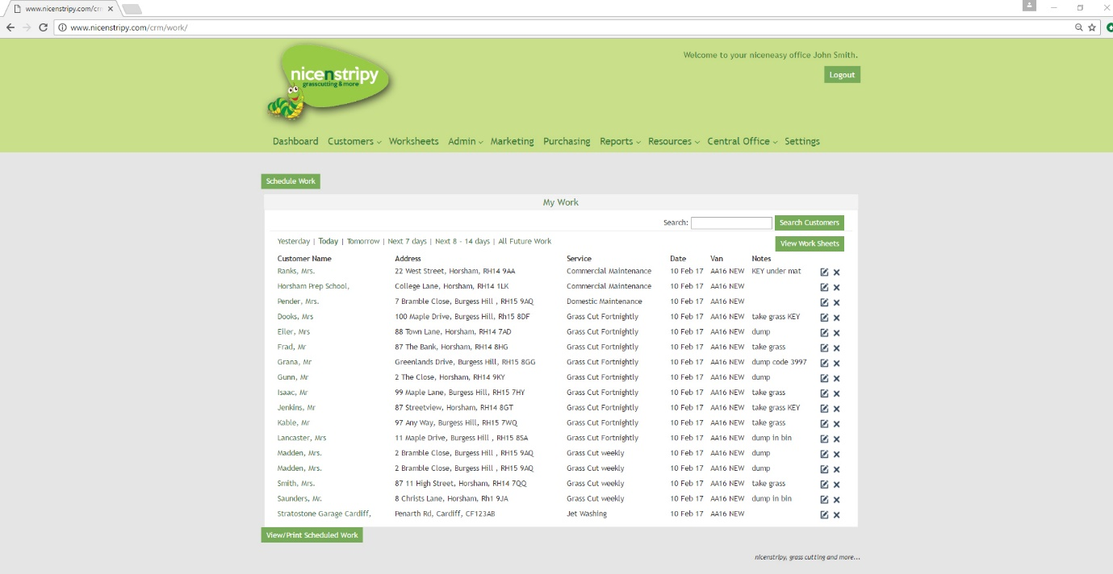
The ‘my work’ home screen allows you to quickly view your scheduled work selecting the relevant links. From this screen there are also buttons to Schedule Work, View Work Sheets and View/Print Scheduled Work. You can also search for a customer from this screen.
Under the listed work you are able to view the customer over view for a selected customer through clicking their name, edit a work item or delete a work item.

Schedule Work
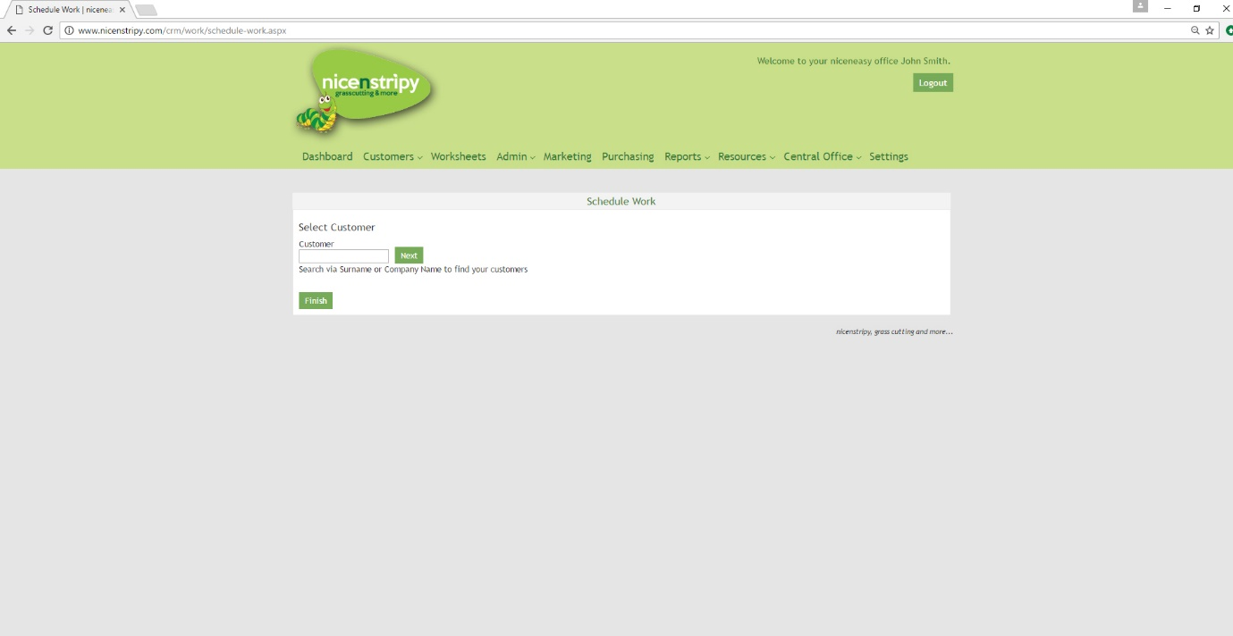
If you click the ‘Schedule Work’ button, you are initially asked to select a customer, you can search your customer database through entering the customer surname or company name. Once two characters have been entered potential customers are shown in a list, as more characters are entered this list becomes shorter. To distinguish between customers with the same name, their post code is also shown.
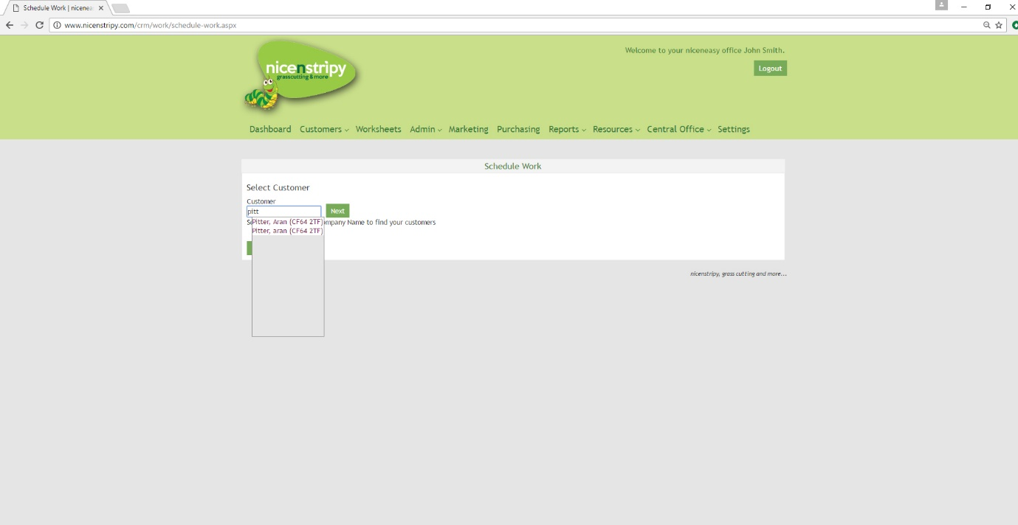
Select your customer and click ‘Next’. You are then taken to screen showing the customer information to ensure you have the correct customer. You are also presented with a number of boxes to complete, the Date of the First Visit, you can assign the work to a Van and the Services information. To reduce the volume of admin, the main services offered by nicenstripy have been pre-loaded onto the system for you.

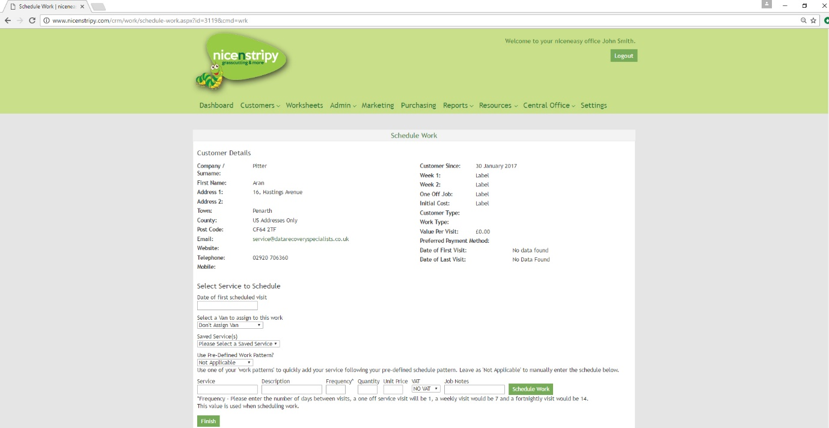
You can also use work patterns when scheduling work. These are explained later in the guide, but are useful for scheduling seasonal work.
Should you attempt to schedule work on or before the current date, you are presented with a warning message that the date for the work has passed. Simply click ‘Yes’ if you are happy to schedule the work or ‘No’ to clear the error message.
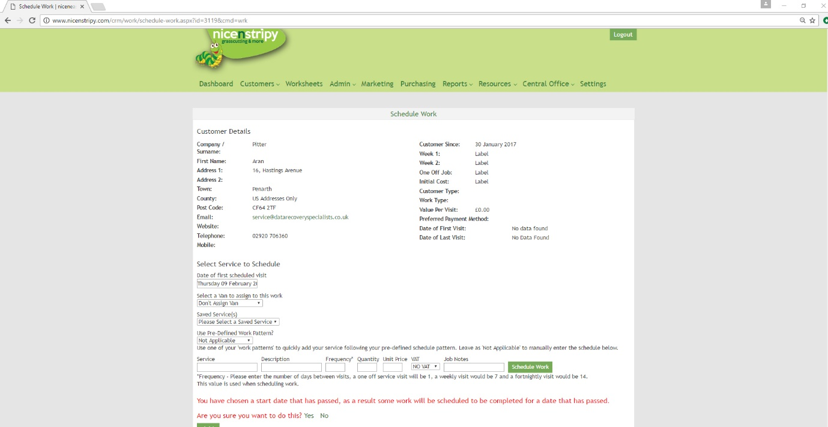
When scheduling work, there are two key fields Frequency and Quantity, depending on the values in these boxes the system will schedule the service to match the number in the quantity box at intervals dictated by the frequency box. So a weekly grass cut would have a frequency of 7 and a default value of 30 for the quantity to cover a full season, the system then adds a weekly grass cut for this customer 30 times every week from the start date specified (date of first scheduled visit). It is possible to edit each job individually if required.
Information entered in the ‘Job Notes’ field is intended for the worksheet and will be recorded against each job.
Once a job has been scheduled a confirmation message will appear and all editable fields will be reset for the next work item.
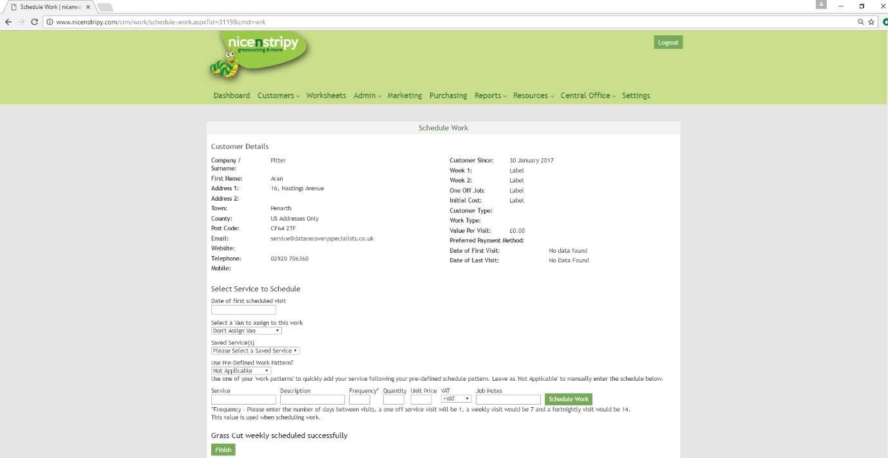
To exit the Schedule Work screen, click the ‘Finish’ button or simply navigate away.
It is also possible to access the Schedule Work screen from a customer page, this will take you directly to the screen to schedule work for your chosen customer rather than having to search for the customer.

Historical Worksheets
Under the ‘Admin’ menu you can view historical worksheets. Here, you can view past worksheets from a single date, and export them if you wish. By default, the date is set one day previously.
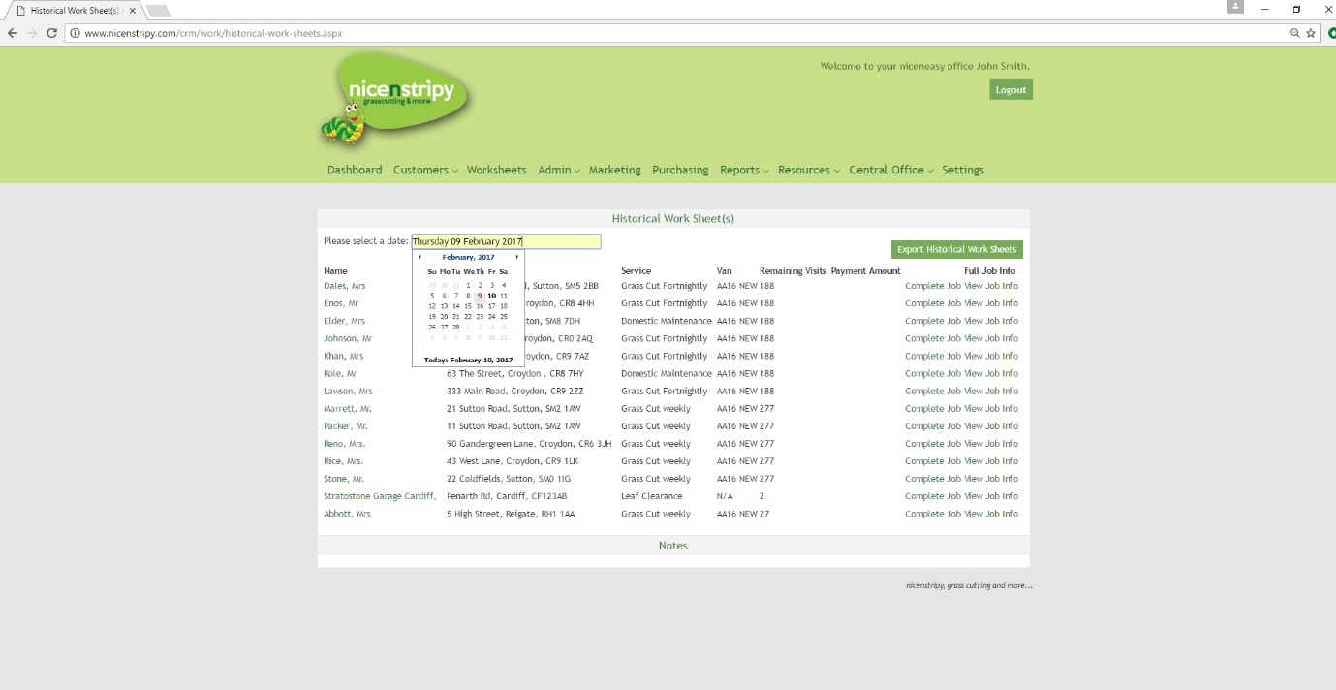

Quotes
The ‘My Quotes’ section shows a quick overview of your quotes and allows you to filter by status, a quote status can be ‘Draft’, ‘Quote Sent’, ‘Approved’ or ‘Removed’, quotes can also show under the expired/declined tab where the expiry date has passed.

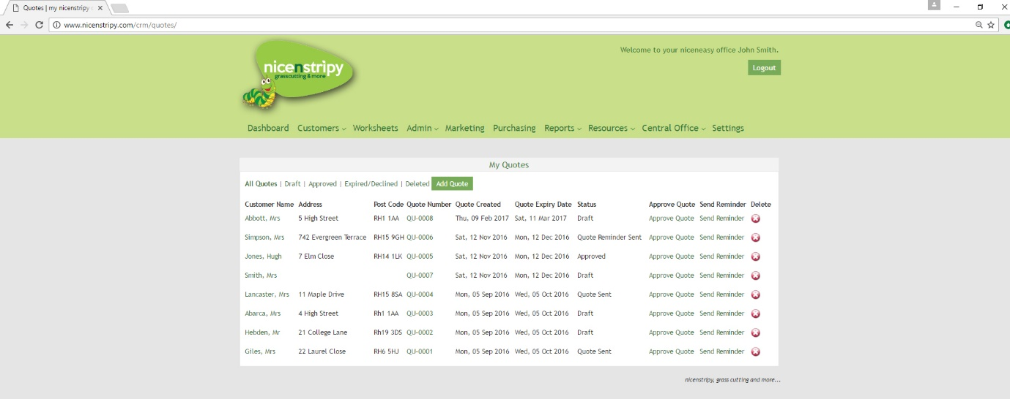
From this screen it is possible to Add a New Quote by clicking the ‘Add Quote’ button, view and edit the quote by clicking a client name or quote number, approve a quote or delete a quote.
If you select to Approve a Quote, the system redirects you to the ‘Schedule Work’ to schedule work for the customer linked to the quote.
You can also send a quote reminder from here.
If you select to delete a quote a warning is presented asking you to confirm the quote deletion.
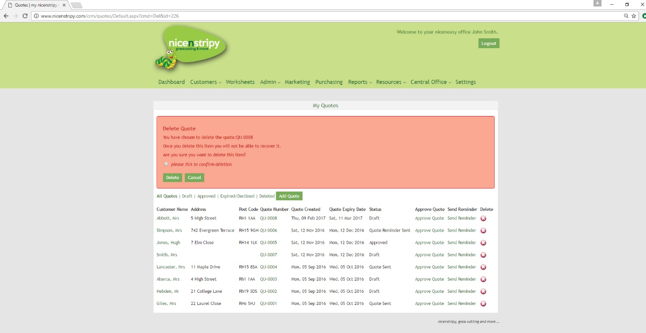
To delete a quote, tick the tick box and click ‘Delete’ the quote is then moved to your deleted pile.
To add a new quote, click the ‘Add Quote’ button. At first you are asked to select your customer, (the customer search works as detailed on page 5), the system will import todays date and set the expiry for 30 days from today’s date. The quote number is automated and will simply be the next number based on the total number of quotes created on the system. The reference field is a free text field and you can enter anything you want.
Click the ‘Next’ button.

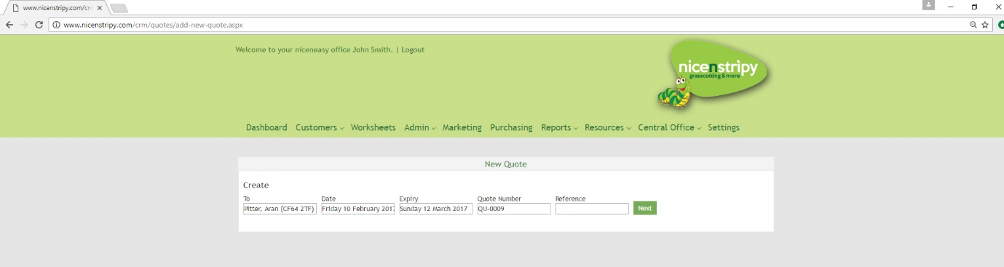
On the next screen you will then see a template to create your quote.
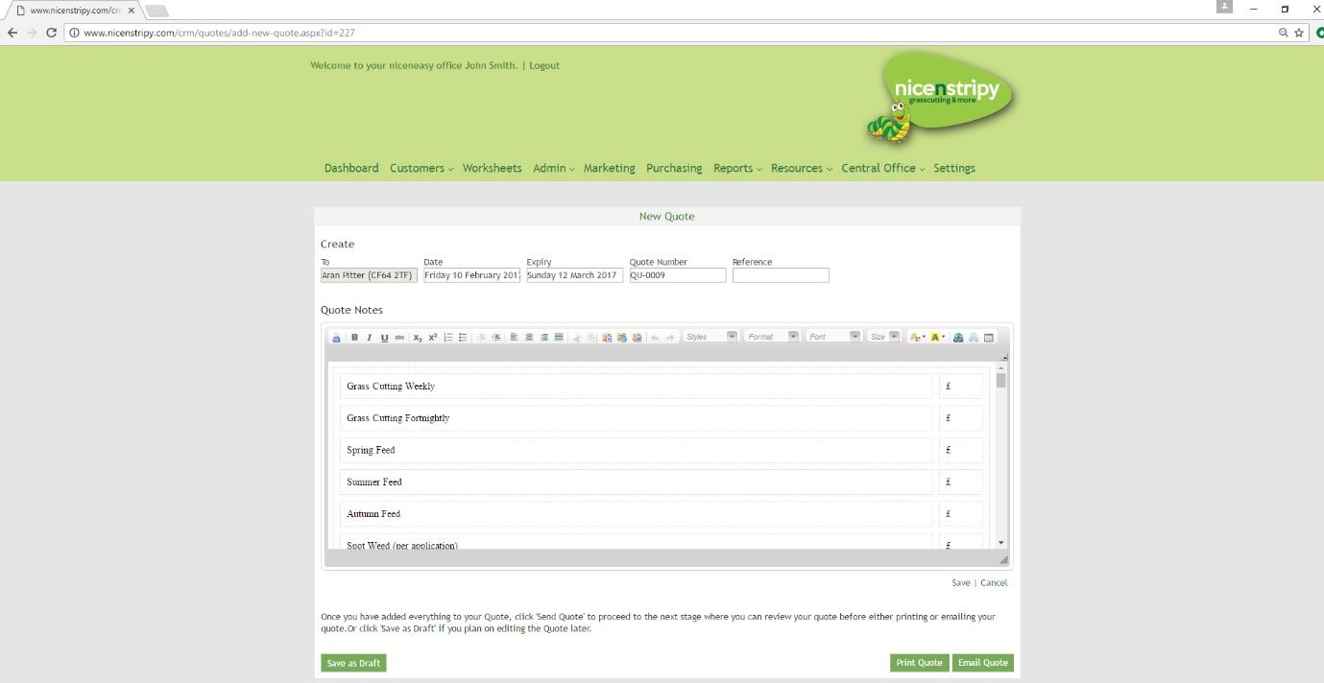
Complete the template to create your quote and click the ‘Save’ button to save the quote. Cancel will return you to the quotes page without saving. ‘Save as Draft’ will save the quote as a draft and return you to the quotes overview page.
Once you’re happy with your quote you can either print the quote to deliver or send in the post or you can email the quote to the customer using the ‘Email Quote’.
If you choose to Email the Quote, the system will pre-load the customers email if available but this can be manually entered, it will also preload a subject and an email with the customer’s details which can be edited. It also loads your details which can be configured in the settings section.
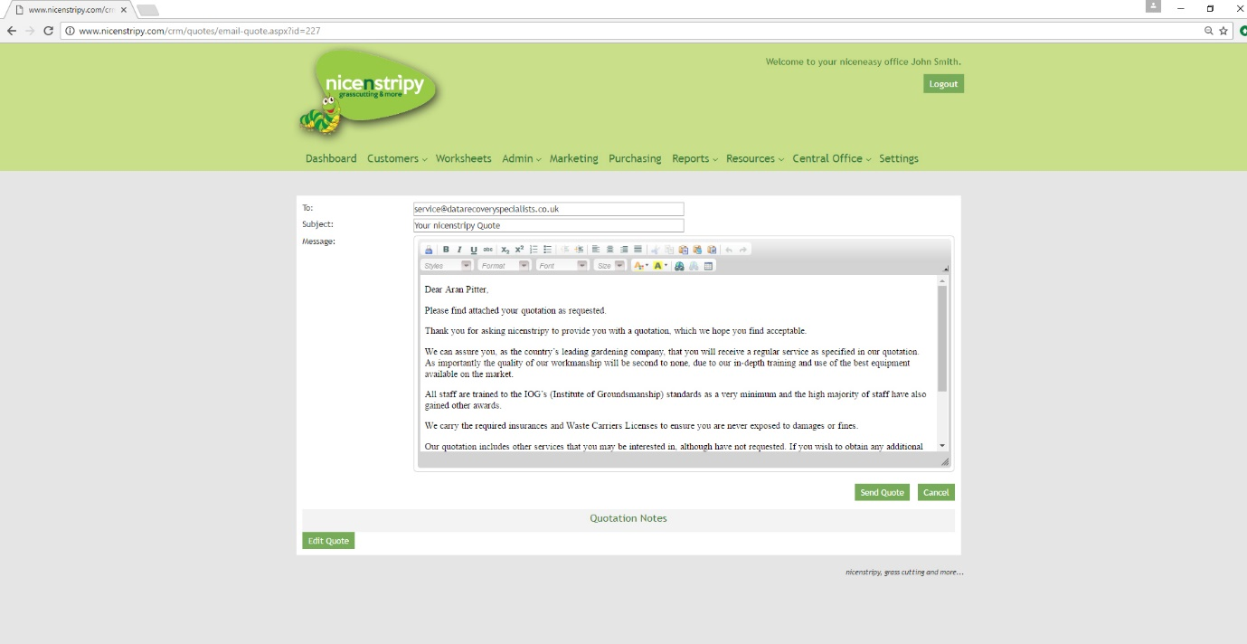
Once a quote has been emailed, you will be redirected to a success screen confirming the email was sent.

My Reminders
This is an extended version of the feature included on the dashboard. Reminders are sorted by ‘outstanding reminders’ and ‘completed reminders’ and you can toggle between the two.

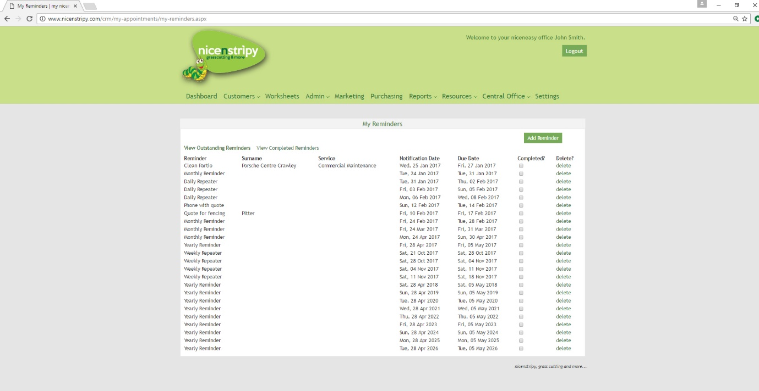
Clicking the ‘add reminder’ button on the top right will take you to a form that allows you to set a reminder pertaining to one of your customers. Upon typing the first two letters of their name, they will appear in a drop down menu, where you can select the correct one. You can set a title for your reminder, a due date, when you want to be notified, and any other notes. You can also tick the ‘repeat reminder’ box if the appointment is regular and you want reminding each time. For example, repeating 4 times per year would add a quarterly reminder throughout the year.
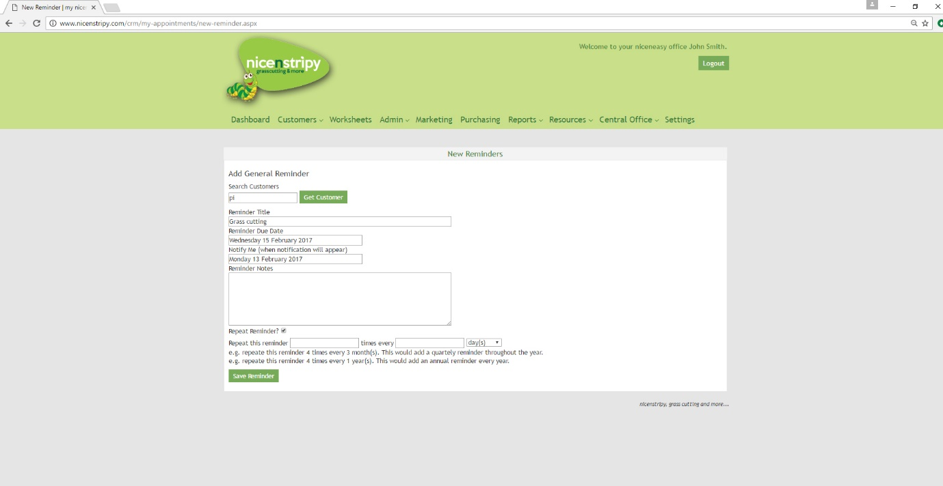
When you click ‘save reminder’, a message will appear telling you that your reminder has successfully been added, and it will now appear in the reminders menu.

My To-do List
Here, you can view existing items on your to-do list and add new ones. These are for simple tasks that can be explained in a sentence. You can tick off items on your to-do list at will – when you do this, they will disappear from your dashboard, but you can uncheck the ‘completed?’ box to make it appear again. When you tick the ‘completed?’ box, the system will tell you the date the item was completed, and which user completed it. You can delete items on your to-do list if you wish.

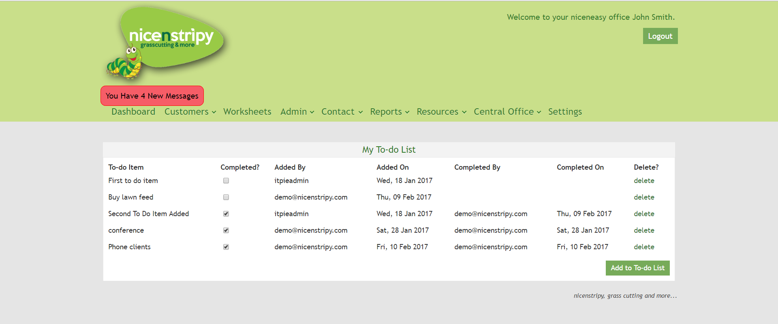

My Appointments
The ‘my appointments’ section gives you an overview of your appointments.

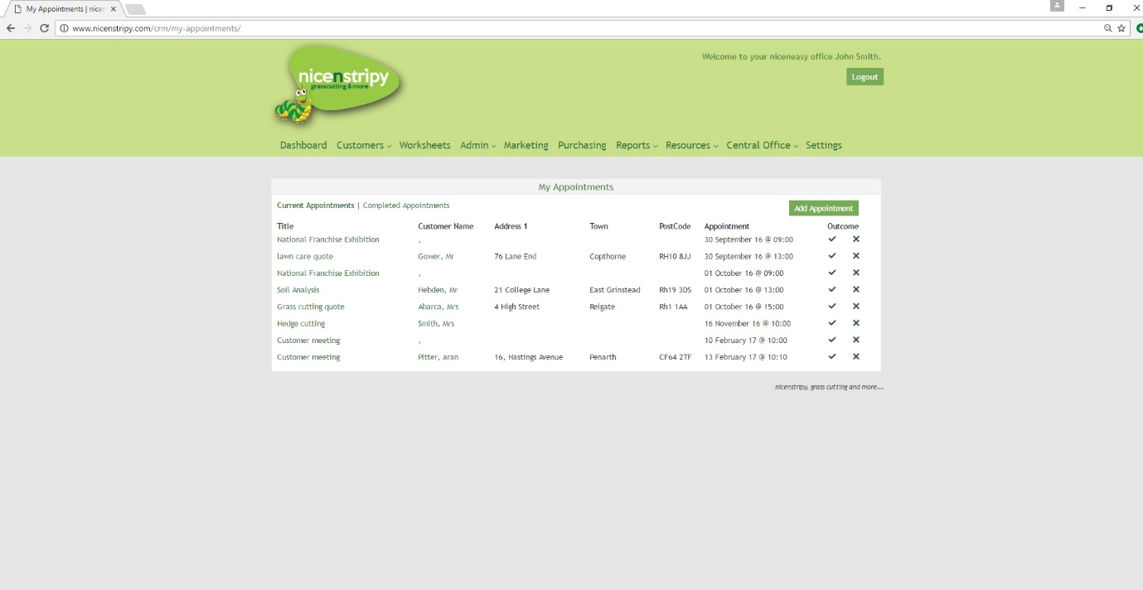

From this screen you can Add an Appointment, view/edit an appointment through clicking the appointment title, view a customer through clicking their name, mark the outcome of the appointment as successful which is then recorded as a presentation on the weekly return or delete an appointment.
If you choose to delete the appointment the system will ask you to confirm that you want to delete the appointment, but will also present you with the option of editing the appointment should you need to re-schedule the appointment.
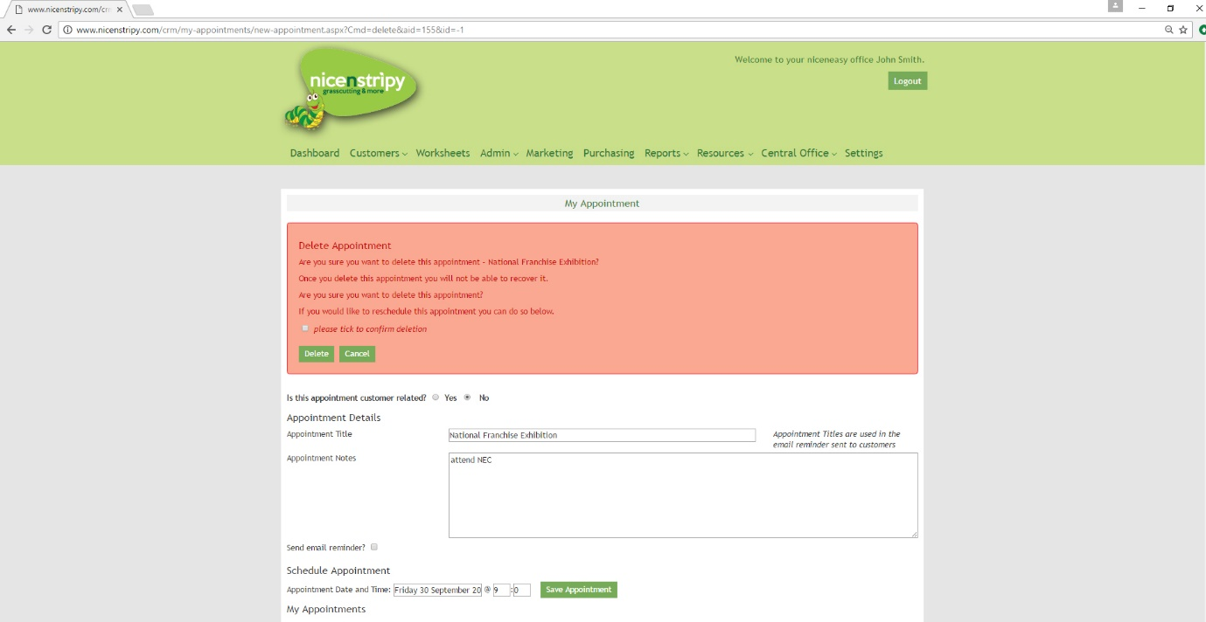
To delete the appointment tick the tick box and click the ‘Delete’ button.
If a quote is marked as success through clicking the tick next to the appointment. If the appointment was linked to a customer, the system will update your weekly return to include a successful presentation and will then redirect you to the quote page to complete a quote for that customer. See Page 13 for quotes.

Add Appointment
It is possible to add customer appointments and non-customer appointments to the system, when you click ‘Add Appointment’ you are first asked if the appointment relates to a customer.
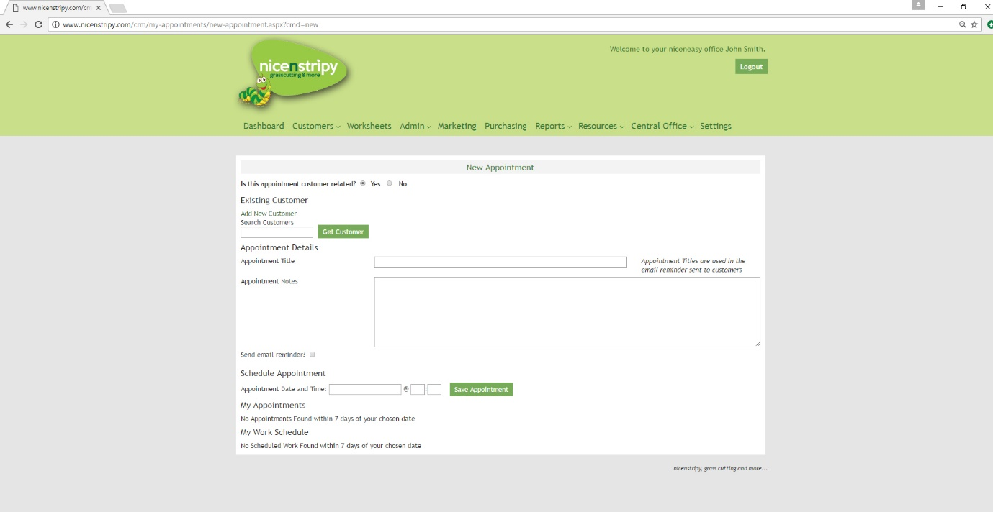

Add New Customer under new appointment screen shot
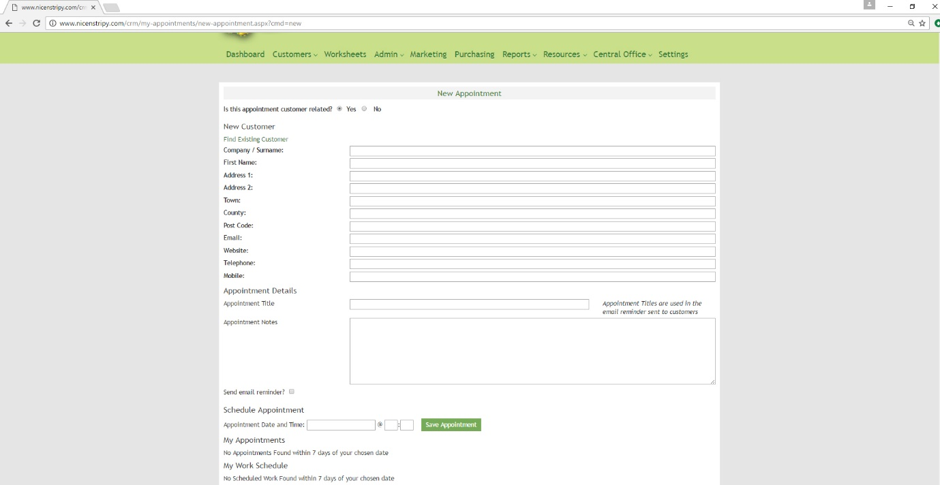
Complete the relevant appointment information and select the appointment date, the system will show you the scheduled work and any appointments within the next seven days once a date has been entered, each time you change the date the system will also refresh your future appointments and work schedule. Enter a time using a 24-hour clock to complete the appointment.
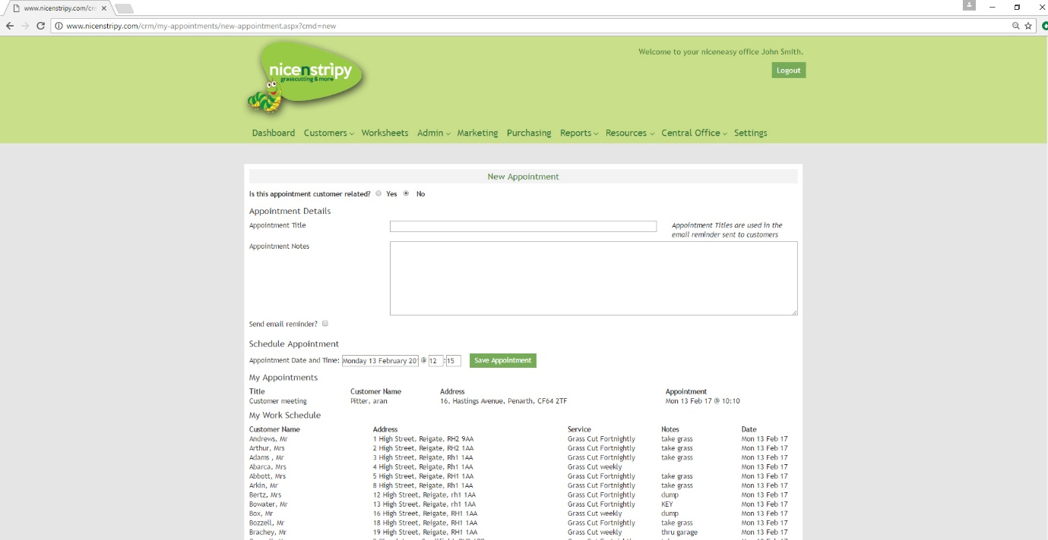
If your appointment is for a customer meeting, you can also opt to send an automated email to the customer reminding them of the appointment 24-48 hours before the meeting. It is important to note that if you opt to use this feature the appointment title along with the date and time will be sent to the customer. If you have not entered an email address the system will flag this up for you. You can edit the customer later to make use of the email reminder feature.

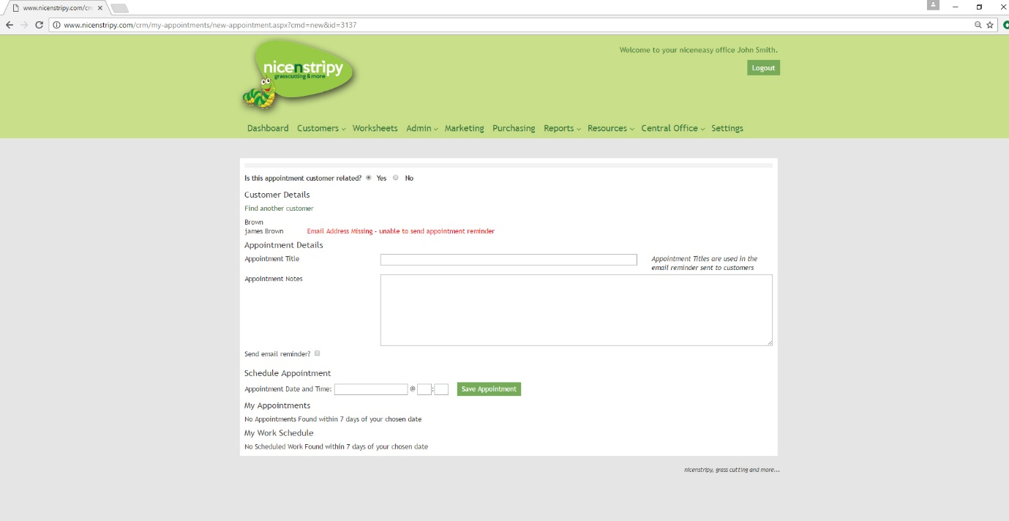

Email Appointment Reminders
Every 24 hours, the system will check for any appointments due within the next 48 hours and send an email reminder, the email will automatically insert the customer’s name, appointment title, date and time of appointment along with your contact details should the customer wish to rearrange the appointment.
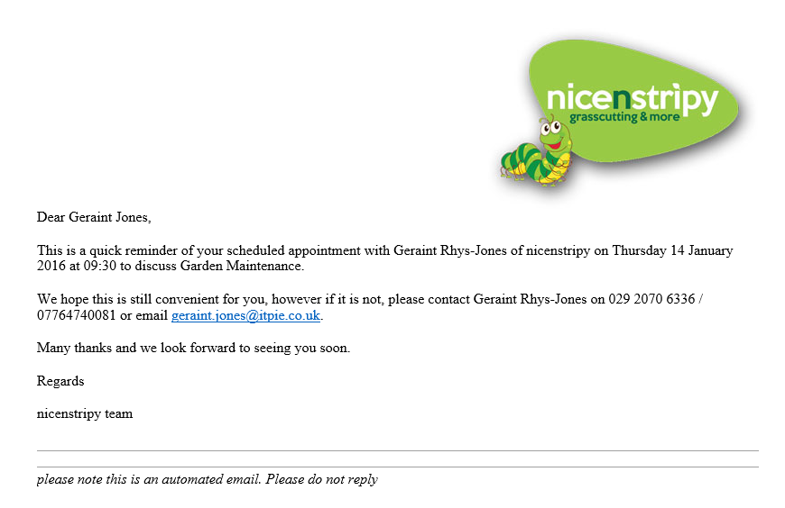

If the system finds an invalid or missing email address it will email you to notify you that it wasn’t able to send a reminder to the customer.
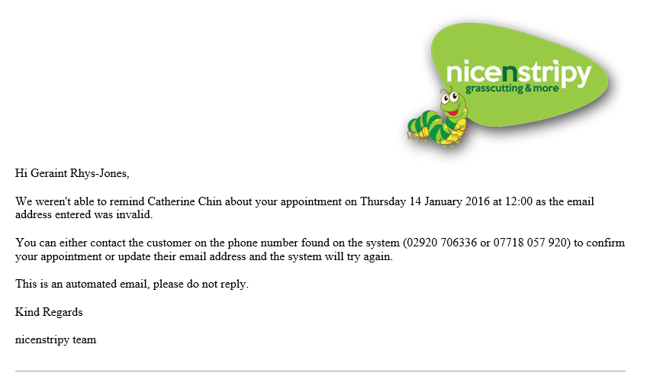

Marketing

Weekly Marketing Checklist
This is where you can keep track of your weekly marketing checklist, to be completed on a weekly basis no later than 12pm on Saturday. Clicking the ‘file weekly marketing checklist’ button will take you to a form to fill in with details from the week’s marketing campaigns. The checklist is primarily in the form of tick boxes, but under ‘leaflets distributed’ and ‘Google Adwords’ there is a text box for you to type how many leaflets you’ve distributed and how much you’ve spent on Google pay-per-click advertising, respectively. You can also add additional notes in the box at the bottom of the form. Clicking ‘update marketing checklist’ will save your changes.

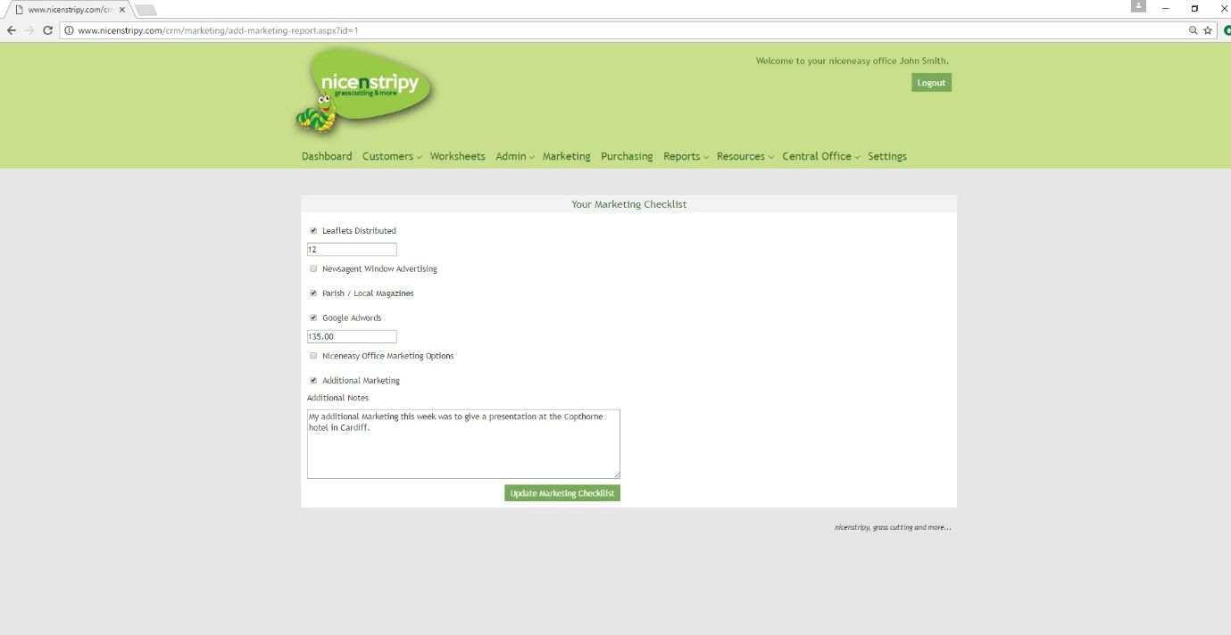

From the ‘Marketing’ landing page, you can view or edit your weekly marketing report.

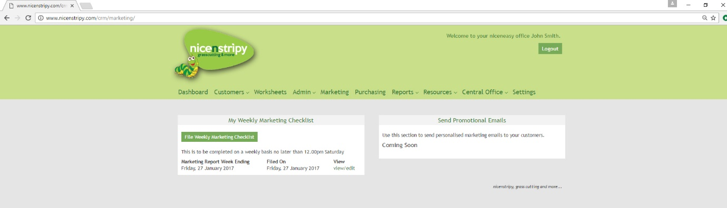

Marketing Templates
Your niceneasy office system also includes an in-built eMarketing system with pre-scripted emails to be used throughout the year. From the marketing dashboard you can either start configuring a new campaign or review your past campaigns which will consist of drafts and sent campaigns.

Marketing Campaign
When you select a new campaign you initially start by composing your campaign. Give your campaign a name you will recognise and then either select from one of the templates or build your own campaign.
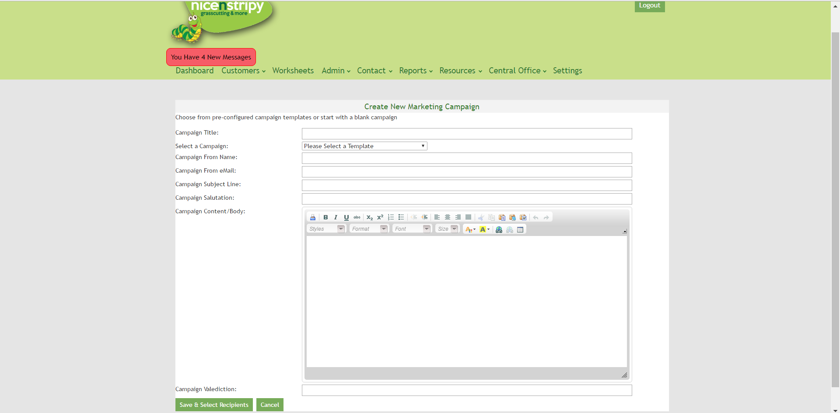
The system will insert the customers name into the salutation and will insert your name and contact details into the valediction when sending to personalise the message.
On the next screen you are asked to choose the recipients of your campaign. You can quickly filter your list via enquiries, active, past and all customers. To add a recipient to the campaign tick the box next to their name. Those customers without a valid email address will be highlighted with a red bar.

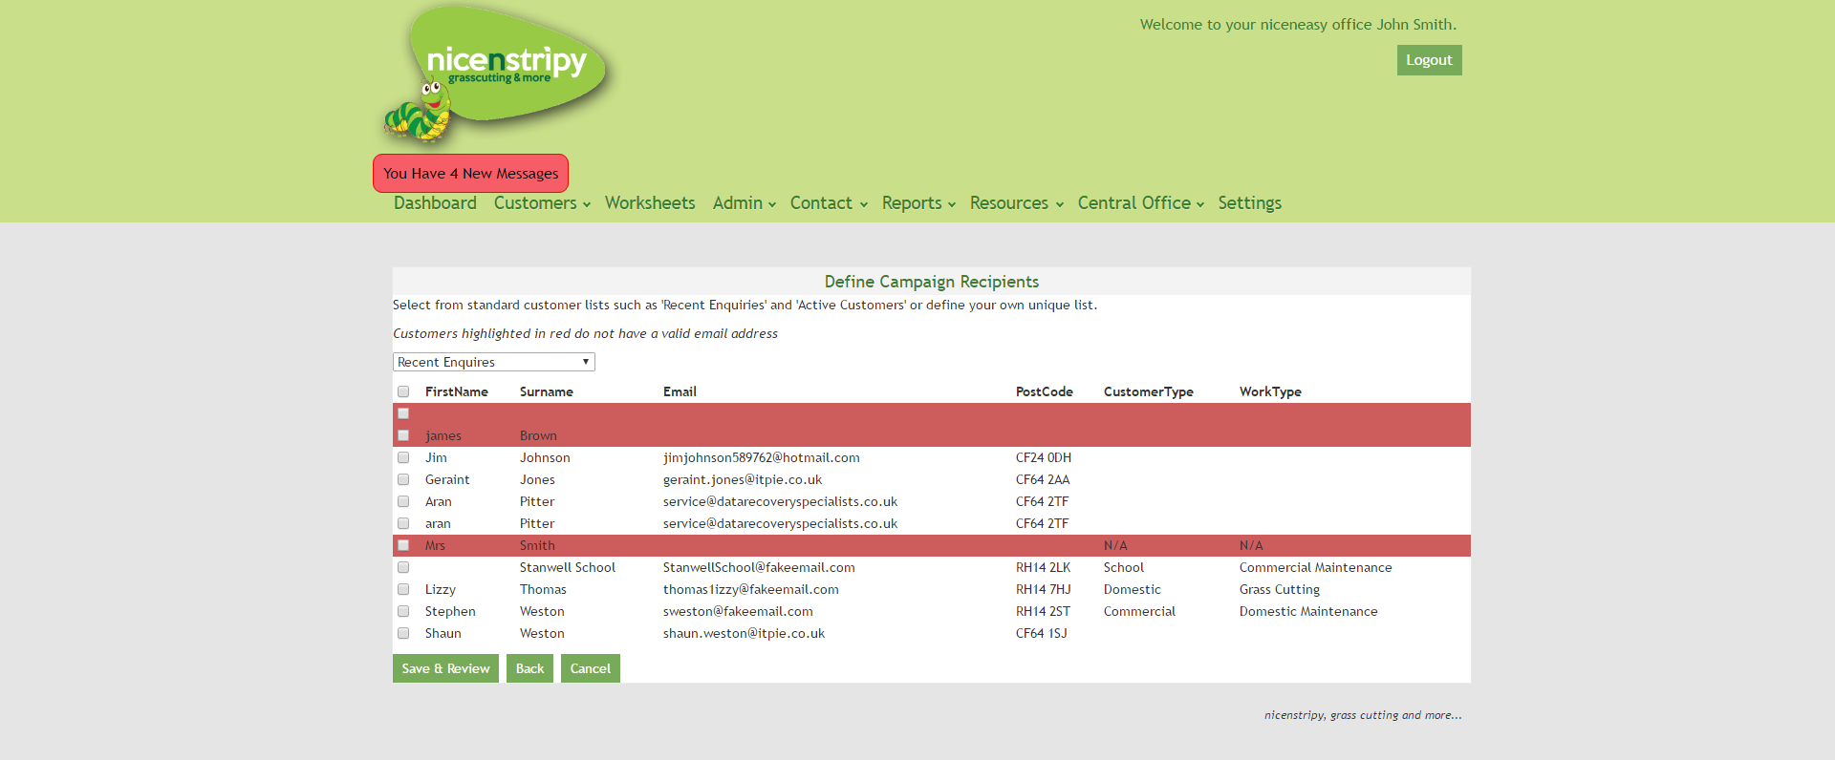

Purchasing
This section allows you to keep track of your recent orders and supplier details, as well as place a new order.

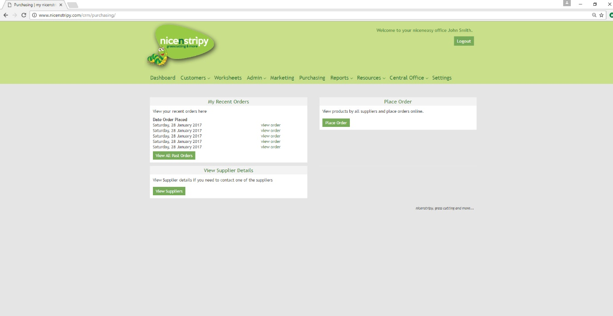

Under ‘recent orders’, you can see the five most recent orders, listed by date, and click the ‘view order’ button to the right in order to view more details. Clicking the ‘view all past orders’ allows you to see all of your orders rather than just the recent ones.

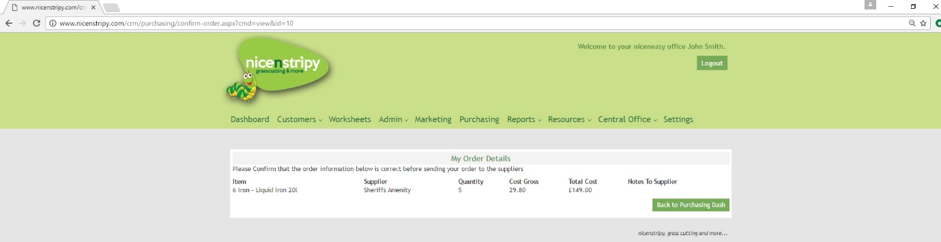

View Supplier Details
Clicking ‘view supplier details’ allows you to view the details of all your existing suppliers. Simply select the supplier to see their full contact details.
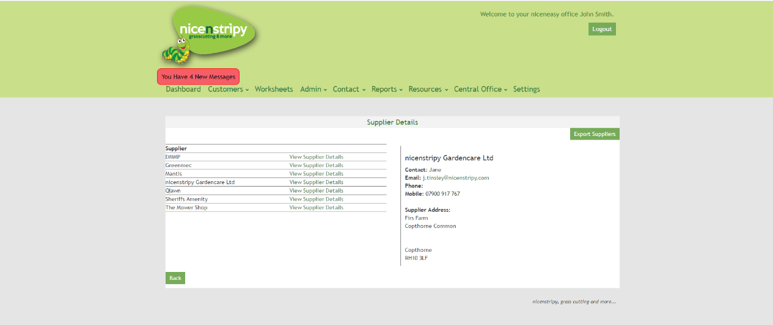

Order Items
Clicking ‘place order’ will take you to the order form. Ordering items is a two step process, first select the items you want to order below and click the 'Order Items' button, you will then be shown a summary screen and asked to confirm your order. Following this second step your order will be emailed to the appropriate suppliers and you will receive a copy of the email. Use the 'Notes to Supplier' section to confirm sizes or any other information required. You can view all items, which is the default, or filter by supplier. If you need to add a message to the supplier there is an additional box under all the items where you can add a further message.
It is important to note that the system is designed to order from one supplier at a time, if you change suppliers using the dropdown menu, selected products will be lost.

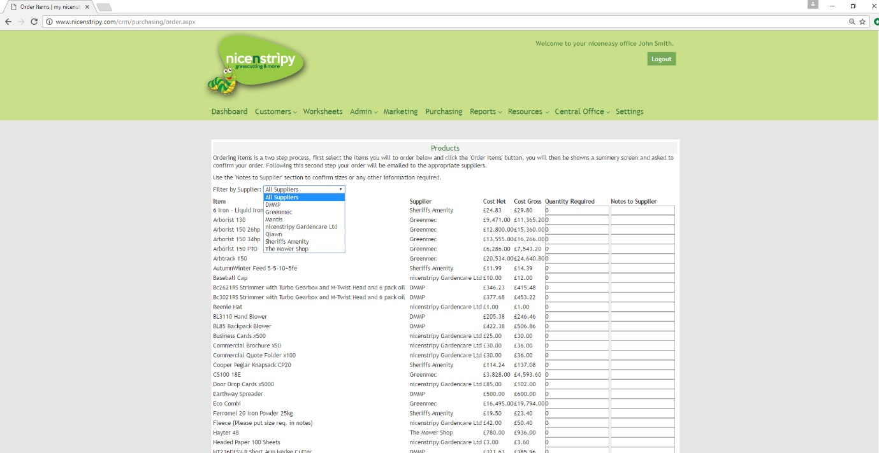
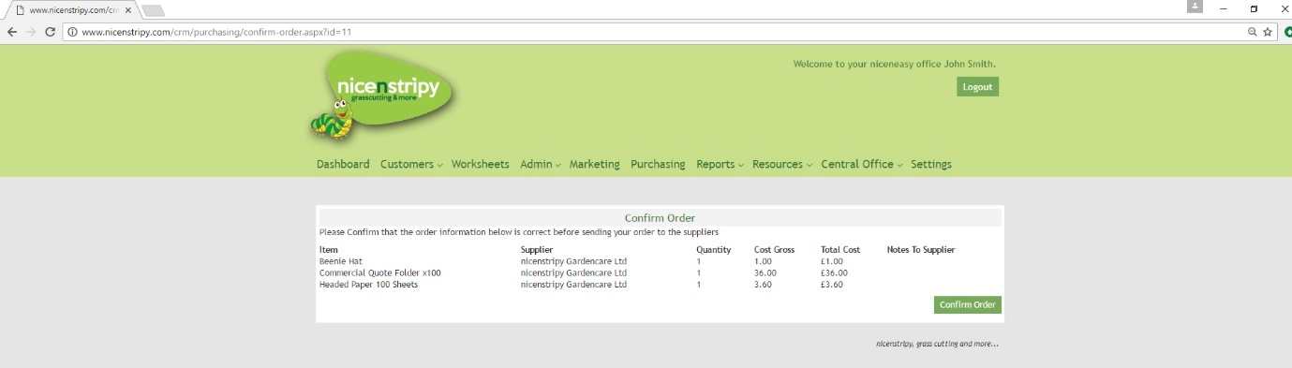

Message System
The niceneasy office system had an internal messaging system, much like an email system you can send a message to another nicenstripy franchisee or partner or a group of users.
The initial screen is your Inbox, you’re able to see draft items and sent items from here. Simply click a message to load it and also view the options.
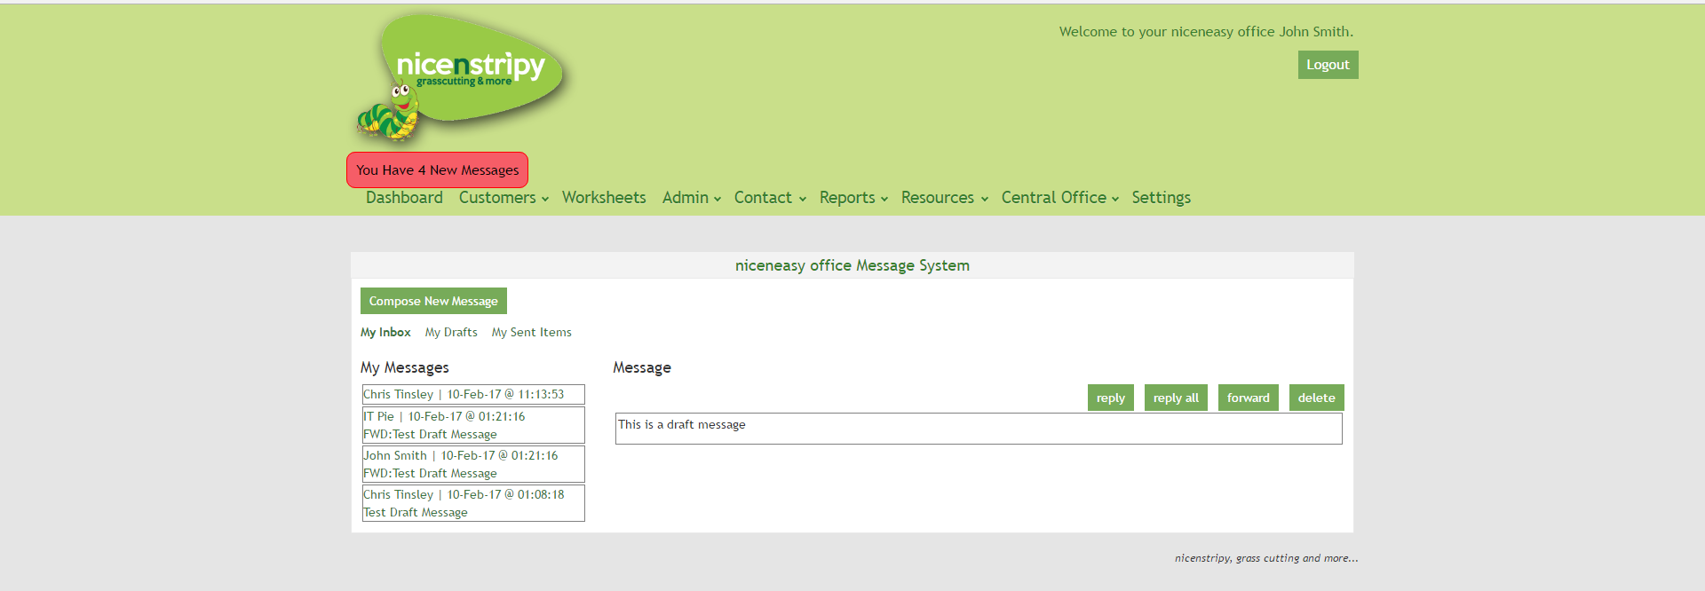
As with emails you can ‘Reply’, ‘Reply All’, ‘Forward’ or ‘Delete the message.
To send a message select the ‘Compose New Message’ button.
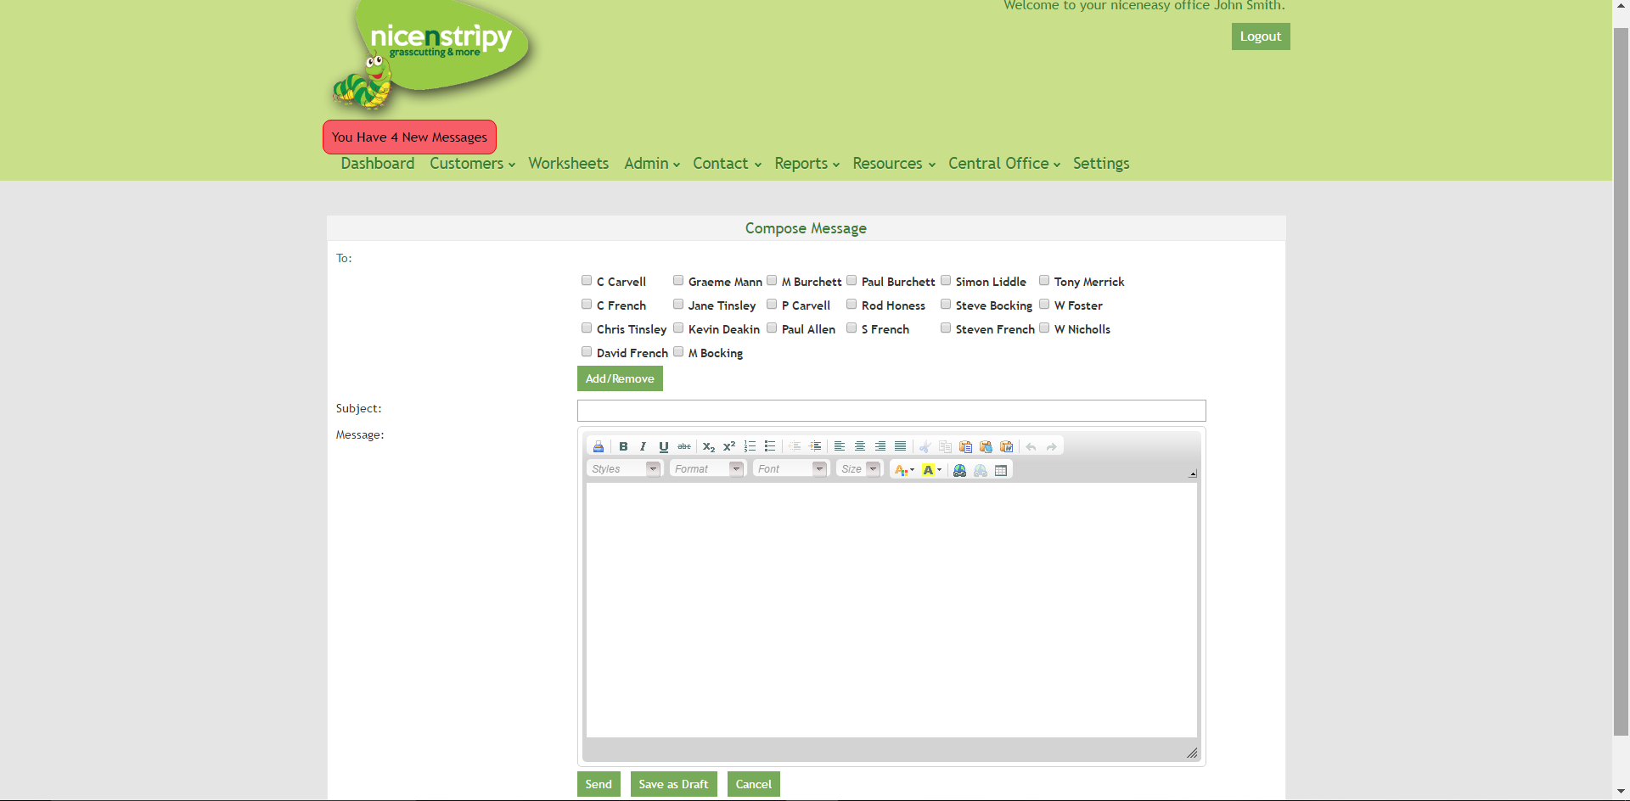
When the new message screen initially loads you can select the recipients by selecting the tick boxes and then clicking the Add/Remove button. Choose a subject line, write your message and then send the message. You can also save as a draft or cancel the message if needed.
Whichever choice you select you will be redirected to your Inbox.

Reports
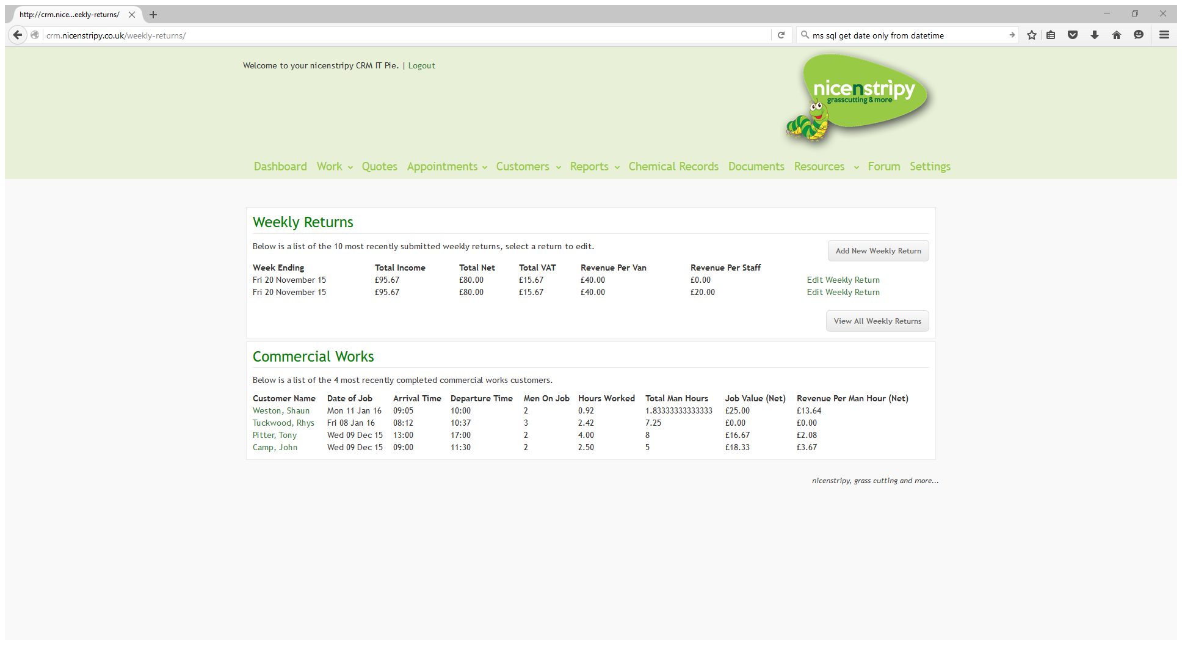

Weekly Returns
It is possible to add a new weekly return or edit an existing weekly return from here.
If you choose to add or edit a weekly return the system pre-populates as much information as possible based on data recorded on the system via appointments and work sheets.
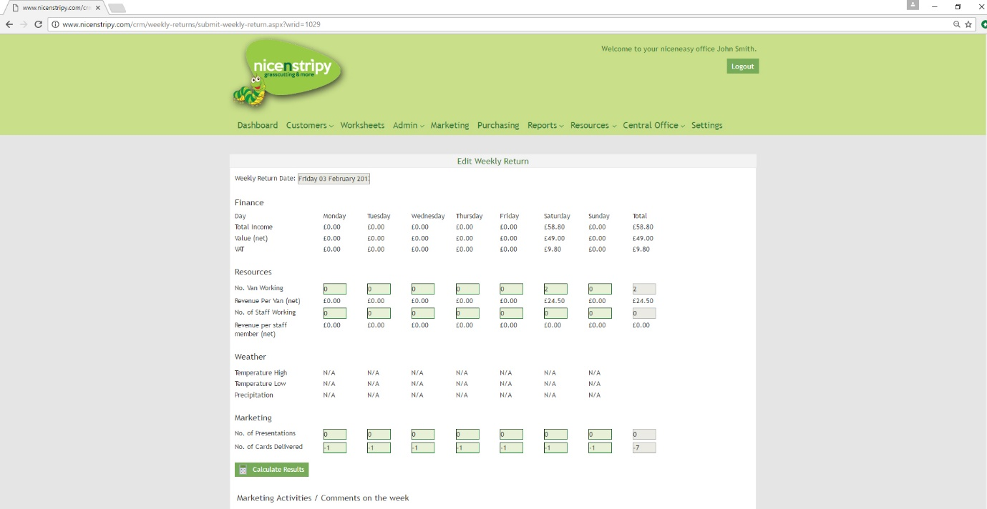

The Finance section is the sum of all completed work for each day.
If Vans have been associated with work their total is included under resources, but you will need to include the number of staff worked each day.
The weather data is pulled from the work sheet.
Marketing shows the sum of all successful appointments/presentations associated with customers but you will need to enter the cards delivered.
An automatic weekly return is generated each week, though franchisees are encouraged to review the figures and update manually.

Commercial Works
If you navigate to the Commercial Works tab from the navigation bar you will see the most recent commercial works completed for each customer along with the total revenue, hours and average revenue per man hour for the commercial work shown. You can click the ‘export commercial works’ button to generate a downloadable spreadsheet.
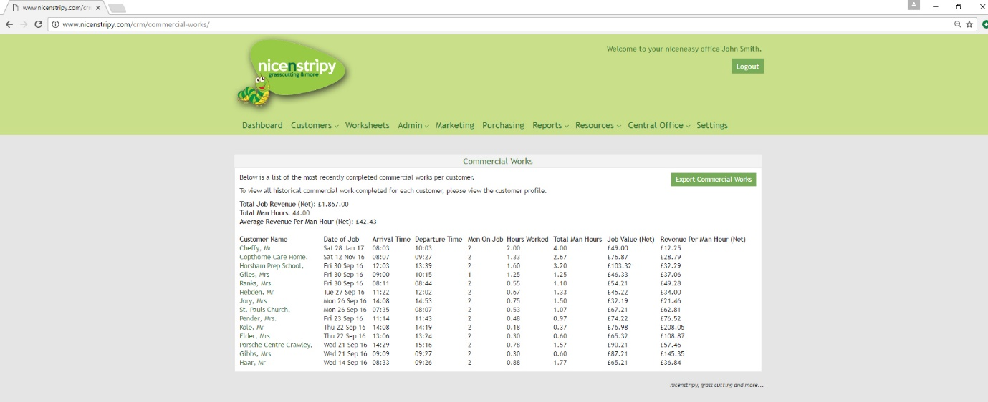
Select a customer to view all commercial work for that customer.

Income Works Analysis
By selecting a data range, you can view the number of jobs delivered within this range, the total income generated and the average price per job. Clicking ‘run report’ will tell you your total net revenue, and how many services you’ve provided within the date range. This can also be generated as a spreadsheet by clicking ‘expert income analysis’.
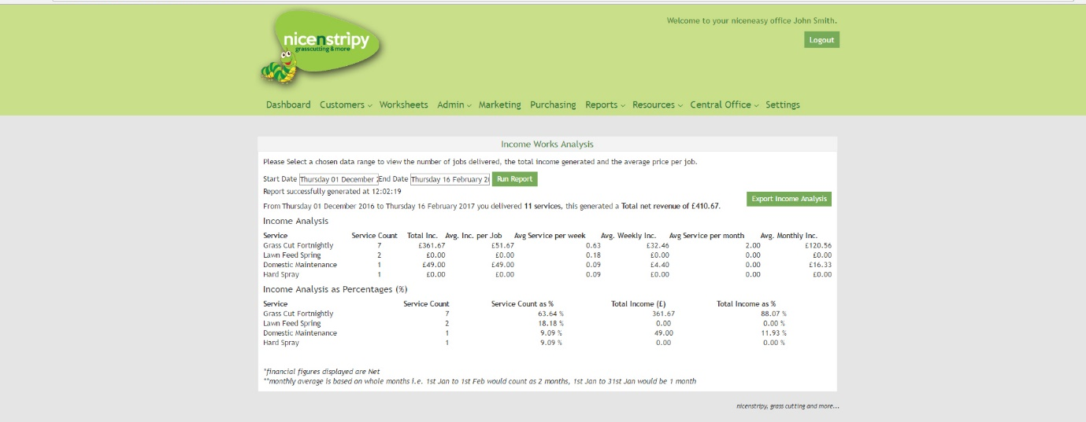

Supplier Spend Analysis
It is possible to analyse your spend on equipment and by supplier. Simply select a data range and click the Run Report button to generate the report.

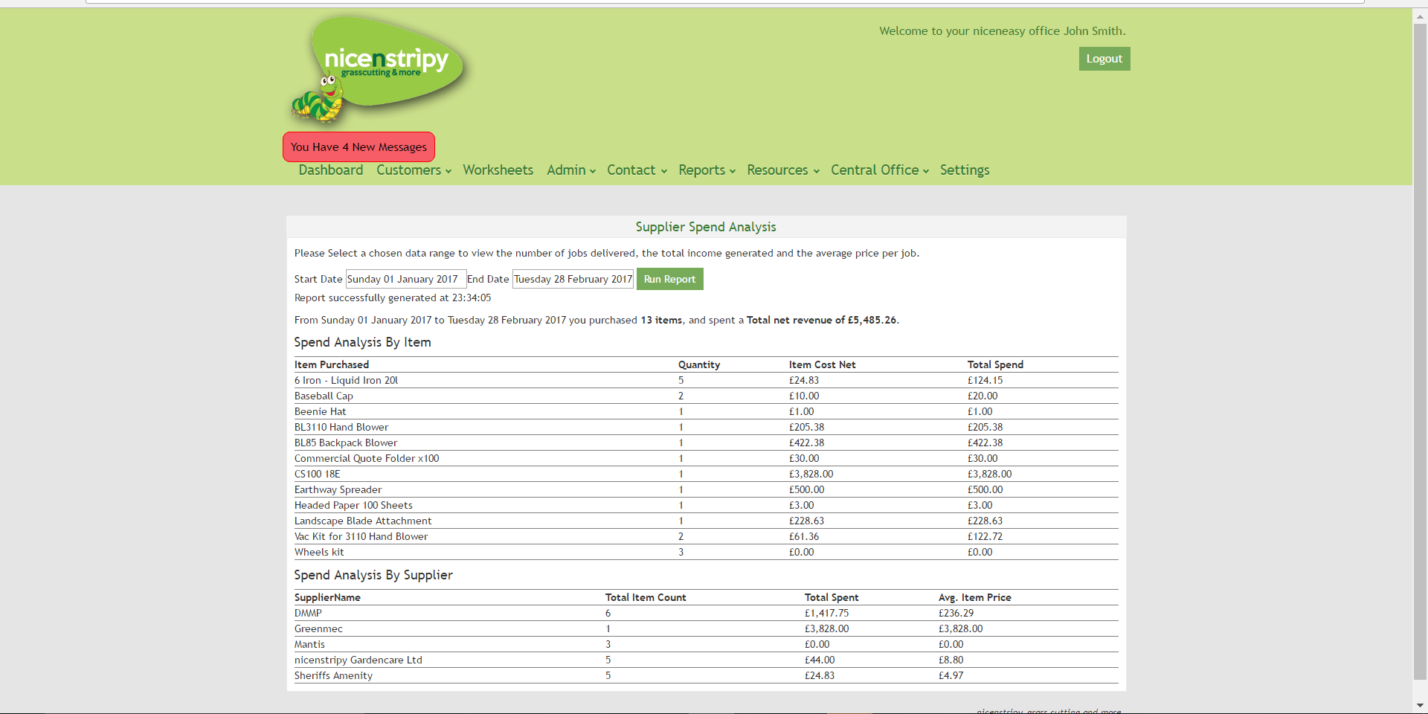

Customer Lead Report
Here, you can view a breakdown of your customer by source, for example, existing customer or a website enquiry. You can export customer sources to a spreadsheet by clicking the button on the right.
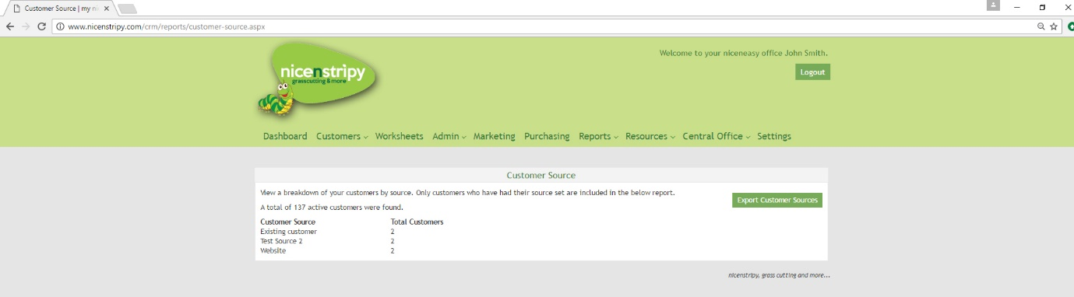

Total Herbicide, Selective Herbicide, Lawn Feed and Pesticide Records
Records for each of these can be viewed from the ‘Reports’ link in the navigation. You can add records, and export records as a spreadsheet.
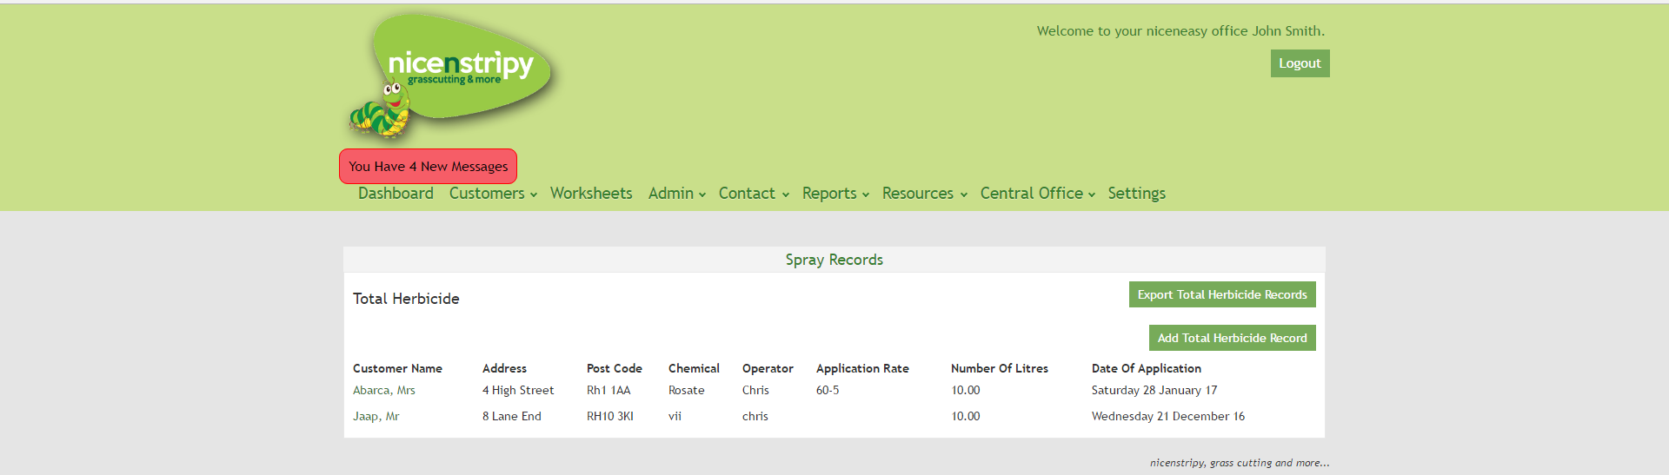

Resources

View Resources
You can view resources such as supplier details, associations, governing bodies, and institutes.
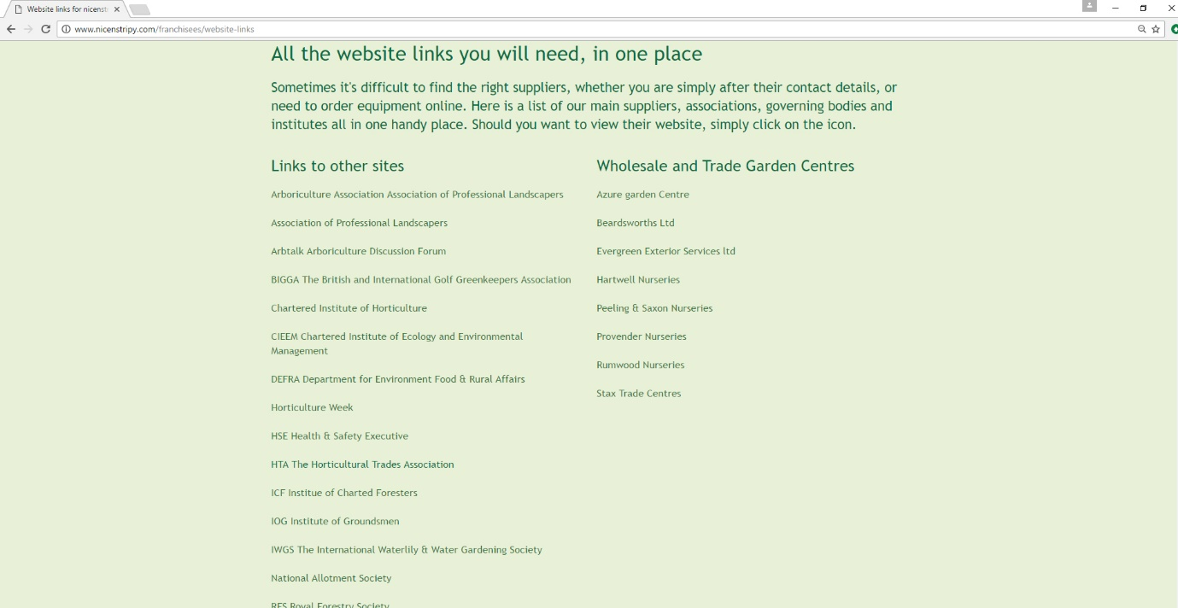

Documents
Clicking ‘documents’ will take you to a repository of operating manuals, marketing manuals, health and safety information, templates, handbooks, risk assessments, instruction manuals, parts diagrams, MSDS chemical safety data sheets, company price lists, sample advertisements, catalogues and brochures.

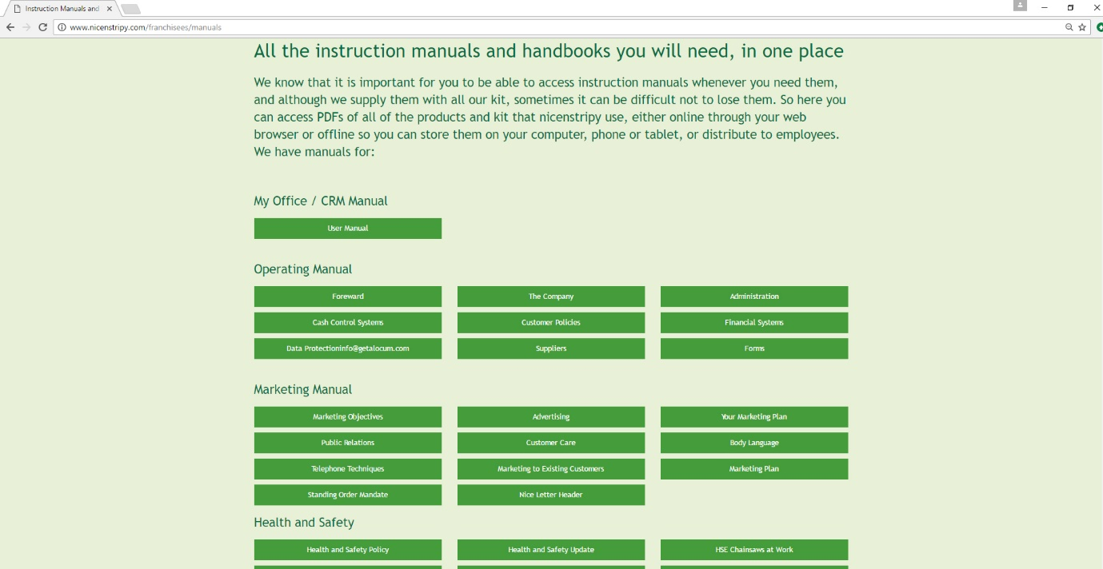

Price List
This will take you to a page where you can download price lists for all nicenstripy suppliers.
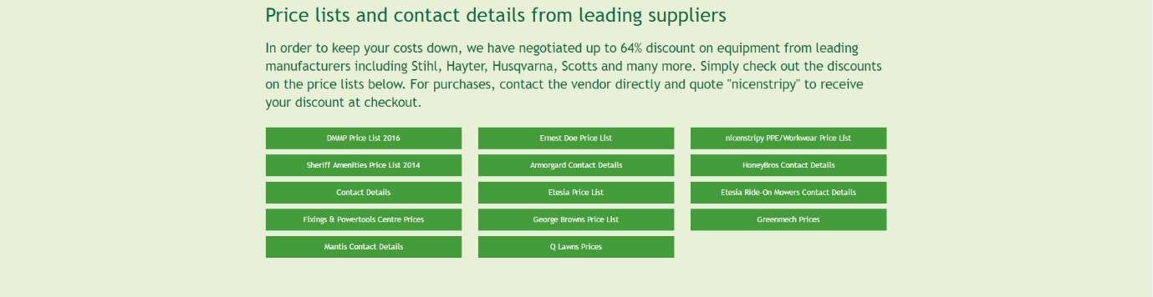

Video
Here you can view important videos relating to operating equipment safely and responsibly.
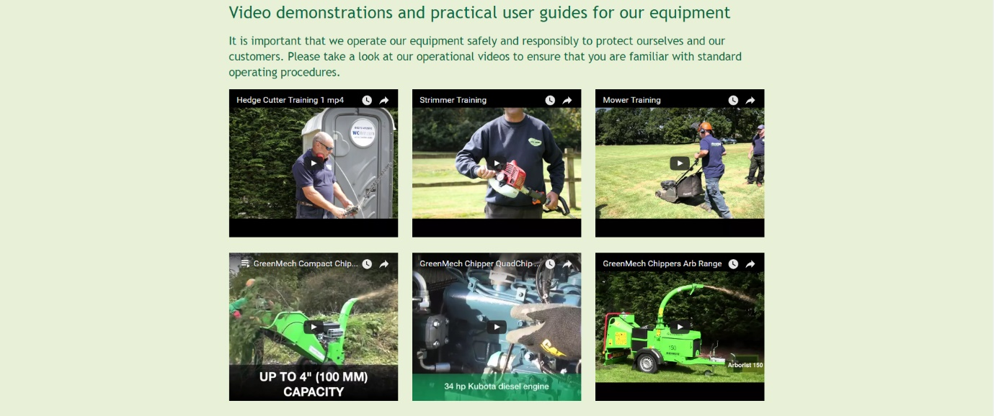

Settings
The settings tab is where you manage your information.
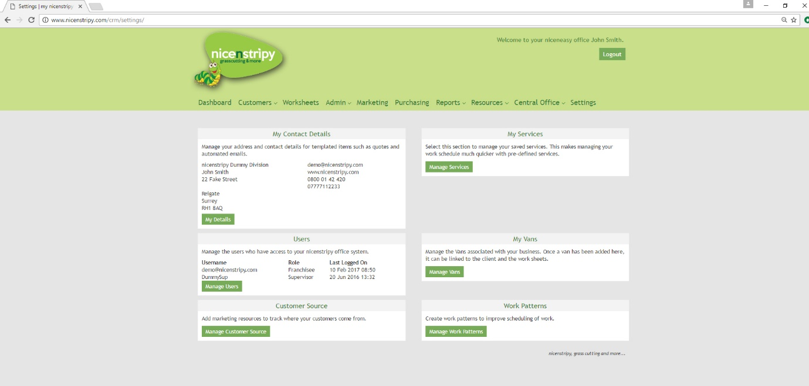

Under settings you can manage your contact details which is used on quotes and emails.
Add services beyond the already pre-programmed services found on the system to make scheduling work quicker.

My Details
Select Manage my Details and you can view and edit your details.
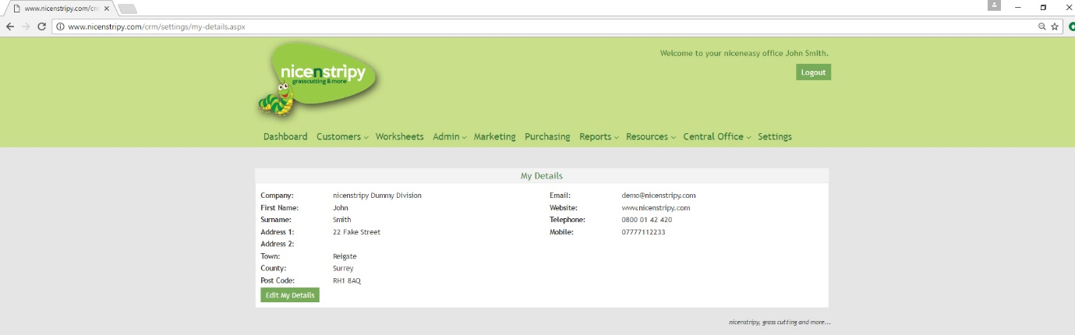

My Services
Add services linked to your account which will then appear in the dropdown menu when scheduling work.
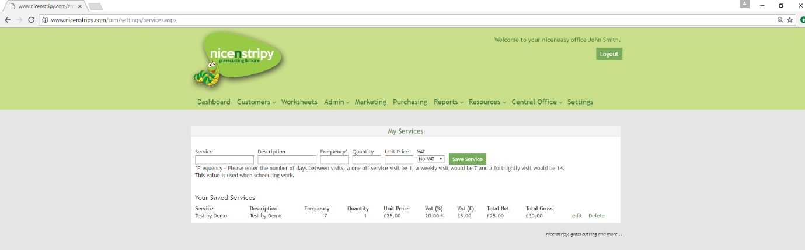

Manage Users
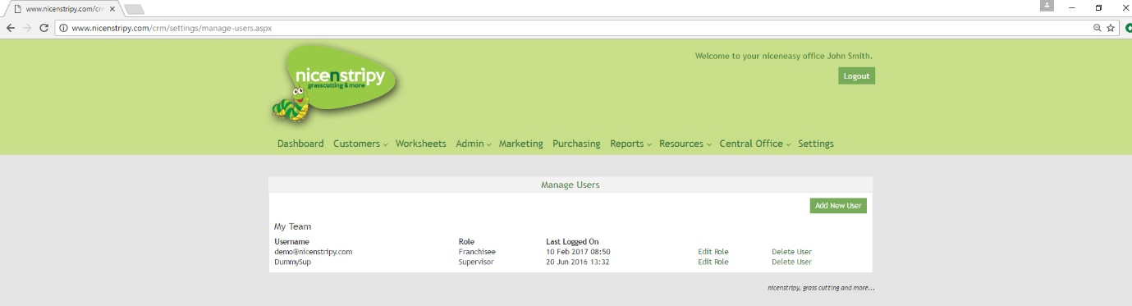
Add, delete and edit user roles. You can give access to staff, change their roles which dictates what access they have and also delete them from the system when needed.

My Vans
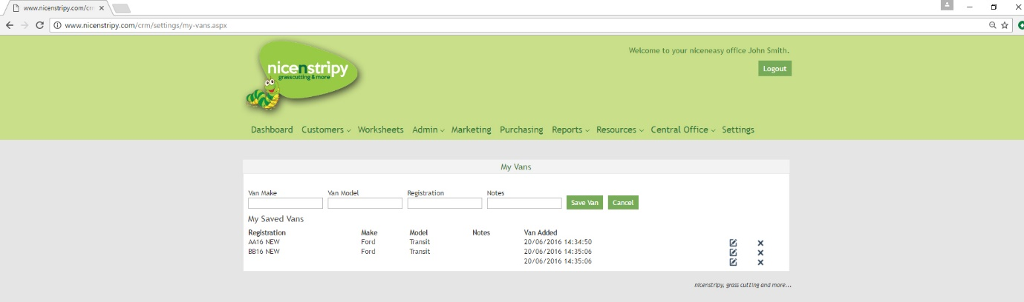
Add Vans to your account which can then be associated with work and will populate your weekly return.

Customer Source
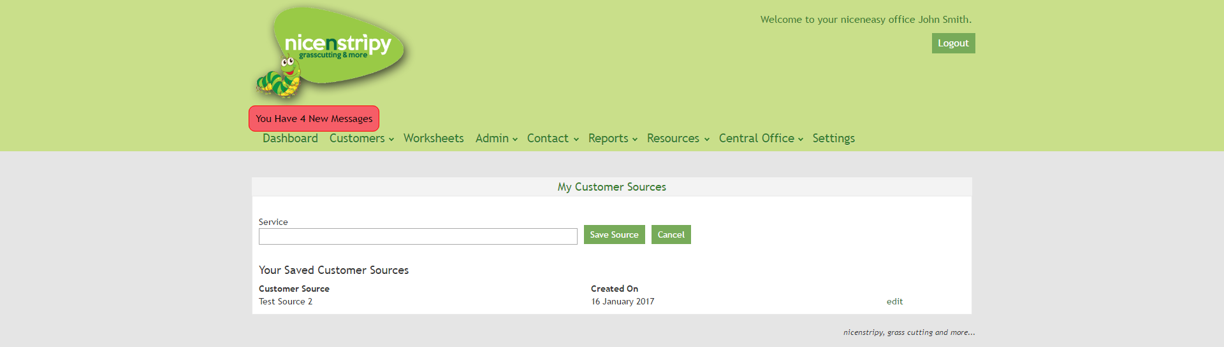
Add your own customer source to track marketing campaigns if the standard range don’t cover your needs.

Work Patterns
It is possible to configure work patterns which makes scheduling work much easier.
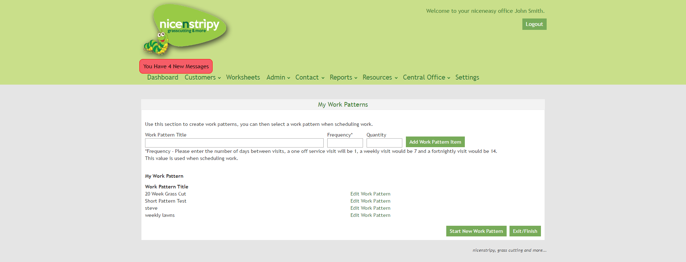
To add a work pattern, give your new work pattern a name and then select the frequency of the first couple of visits and the quantity, then click the ‘Add Work Pattern Item’. This will be saved as Stage 1 and you can then add further stages. There is no limit to the number of stages that can be added to a Work Pattern and as mentioned earlier in the guide, these are then used when scheduling work.
An example work pattern is a seasonal grass cut, this might consist of 4 fortnightly cuts (stage 1), followed by 12 weekly cuts (stage 2) completed with a further 4 fortnightly cuts (stage 3).

