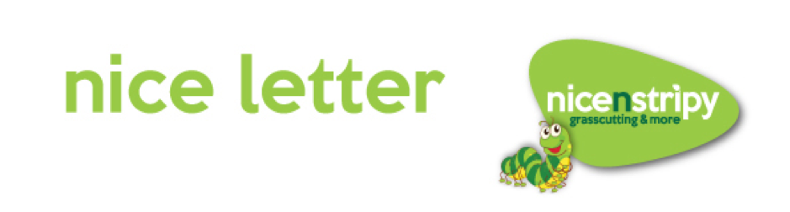

Customer Name
Address Line 1
Address Line 2
Town
County
Postcode

Date

Dear Customer Name

Happy new year! Our grass cutting season will start at the end of February and end late November/ early December dependant on weather and growth. Please find below our prices for the season, along with our various package options. Should you require any more information, or indeed to cancel our services please contact Chris. We look forward to working with you for another year.

Day of Visit DAY

First Visit Date DATE

Pay As You Go

Grass Cutting (per cut)…………………………………………………………………….£
Lawn Feed per treatment (x3 yearly)……………………………………………...£ plus VAT
Weed treatment per application…………………………………………………….£ plus VAT
Scarification……………………………………………………………………………………£ plus VAT

Payment is due on completion of cut unless you are on standing order, where payments are made monthly. Payment can be made by cash or cheque to your operators, posted to the usual YOUR TOWN address, or by online banking. For online banking please see details on the invoice provided, and please include your surname as reference so we can identify who the payment has come from. Cheques to be made out to nicenstripy. Please visit www. nicenstripy.com for our full terms and conditions.
Kind Regards

YOUR NAME
Packages

Packages are worked out over 12 monthly payments based on services for the year. Payments start in March of this year and end February next year.

Package | Whats Included? | Cost
carentreat | 3x Lawn feeds, 1x weed treatment and the option to add scarification | £pcm
Grass Only Fortnightly | Fortnightly lawn cutting | £pcm
Grass Only Weekly | Weekly lawn cutting | £pcm
carencut Fortnightly | 20x lawn cuts, 3x lawn feeds and 1x weed treatment | £pcm
carencut Weekly | 30x lawn cuts, 3x lawn feeds and 1x weed treatment | £pcm
carencut Platinum | 30x lawn cuts, 3x lawn feeds, 2x weed treatments and scarification | £pcm
Full Garden Maintenance | Grass cutting, lawn care and monthly visits to weed beds, cut hedges, clear weeds from paths and patios and much more | £pcm

We can also build any extra services such as pressure washing, gutter clearance or hedge cutting into any of the above packages if required.

Should you require any assistance choosing the right option for you, please do not hesitate to get in touch.

Mobile – YOUR MOBILE
Freephone – 0800 014 2420
Email – YOUR NAME@nicenstripy
Website – www.nicenstripy.com
Find us on Facebook @ Nicenstripy UK

